OZONE User’s Guide

Publication/Revision History

|  |  |
| --- | --- |
| Release | Date |
| Revised – OZONE 7.6.0 | December 10, 2013 |
| Initial Document – OZONE 7.5.0 | November 26, 2013 |

Note: This guide addresses the OZONE Widget Framework (OWF) and AppsMall/Marketplace “Store” products.

Table of Contents

OZONE User’s Guide 1

Table of Contents 3

Figures 5

Tables 7

1 Overview 8

1.1 What’s New 9

1.2 Objectives 10

1.3 Document Scope 10

1.4 Related Documents Table 10

1.5 Requirements 11

2 Getting Started 12

2.1 First Time Experience 12

2.2 Use OWF and the Store 13

2.2.1 OWF Overview 13

2.2.2 Store Overview 14

2.3 Product Components 15

2.3.1 OZONE Banner (OWF) 15

2.3.1.1 Toolbar (OWF) 16

2.3.1.2 Drop-down User Menu (OWF) 17

2.3.1.3 Drop-down User Menu (Store) 17

2.3.2 Discovery Page (Store) 18

2.4 Footer (Store) 20

3 Search & Discovery (Store) 21

3.1 Overview of Search 21

3.2 Search for Listings (Store) 21

3.2.1 Search Affiliated Stores (Store) 21

3.2.2 Search Options (Store) 22

3.2.2.1 Filters (Store) 22

3.2.2.2 How filters change Search Results (Store) 23

3.2.2.3 Sort Icons (Store) 23

3.2.3 Search from the Browser (Independent Store) 24

3.2.4 Search Results Display Options (Store) 24

3.3 Expanded Explanation of Search (Store) 25

3.4 Additional Search Information (Store) 27

3.5 Lucene index search terms (Store) 27

4 Listings: Add, Create, Review (Store) 30

4.1 Listing Overview (Store) 30

4.2 Listing views (Store) 30

4.2.1 Short Listing View (Store) 30

4.2.2 Quick Listing View (Store) 31

4.2.2.1 Listing Details (Store) 32

4.2.3 Detailed Listing View (Store) 32

4.2.4 My Listings Page (Store) 33

4.2.4.1 My Listings Page Terms (Store) 34

4.3 Add Listings to OWF (Store) 35

4.3.1 Start/Add a Web App (Store) 36

4.4 Review Listings (Store) 36

4.4.1 Add Comments (Store) 36

4.4.2 Add Ratings (Store) 37

4.5 Create Listings (Store) 38

4.5.1 Walkthrough: Create a Listing (Store) 38

4.5.2 Save Incomplete Listing Form (Store) 43

4.5.3 Submit a Listing for Approval (Store) 44

4.6 Edit Listings (Store) 44

4.6.1 Edit Approved Listings (Store) 45

4.6.2 Edit Pending Listings (Store) 46

4.7 Required Listings (Store) 48

4.7.1 Assign Required Listings (Store) 48

4.7.1.1 “Required by” Association (Store) 50

4.7.1.2 Required Listings in the Change Log and My Listings 50

5 Applications: Start, Edit, Delete, Share (OWF) 51

5.1 Application Overview (OWF) 51

5.1.1 Application Pages Overview (OWF) 51

5.2 My Apps Menu (OWF) 53

5.2.1 Start Apps and Pages (OWF) 54

5.2.2 Reorder Apps and Pages (OWF) 55

5.3 App Information Window (OWF) 56

5.3.1 Add a Page to an Application (OWF) 56

5.3.2 Push/Share Apps (OWF) 57

5.3.2.1 Push Apps to the Store (OWF) 57

5.3.2.1.1 Push Updates to the Store (OWF) 58

5.3.2.2 Share Apps in OWF (OWF) 58

5.3.2.3 Restore an App or Page (OWF) 59

5.3.2.4 Edit an App or Page (OWF) 59

5.3.2.4.1 Rename an Application (OWF) 60

5.3.2.5 Delete an App or Page (OWF) 60

6 Create an App (OWF) 61

6.1 App Builder Components (OWF) 63

6.1.1 App Layout Dividers (OWF) 63

6.1.2 App Layout Types (OWF) 64

6.1.3 Accordion Layout (OWF) 64

6.1.4 Desktop Layout (OWF) 65

6.1.5 Portal Layout (OWF) 66

6.1.6 Tabbed Layout (OWF) 66

6.1.7 Fit Layout (OWF) 67

6.2 Use the App Builder (OWF) 67

7 App Components (OWF) 70

7.1 Definitions 70

7.1.1 App Components 70

7.1.1.1 Singleton App Components 70

7.1.1.2 Background App Components 70

7.1.1.3 Required App Components (OWF) 71

7.2 App Component Menu (OWF) 71

7.2.1 Search for App Components (OWF) 72

7.2.2 Reorder App Components in the App Component Menu (OWF) 73

7.3 Start App Components (OWF) 73

7.3.1.1 Intents: Start App Components that use them (OWF) 73

7.4 Send Apps to the Store (OWF) 74

7.5 Delete App Components (OWF) 75

7.5.1 Deleting Required App Components (OWF) 76

8 Customize your experience 76

8.1 Update your Profile 76

8.1.1 User Profile (Store) 76

8.1.2 User Profile (OWF) 78

8.2 Change themes 78

8.2.1 Themes (Store) 78

8.2.2 Themes (OWF) 80

8.2.2.1 Accessible Themes (OWF) 80

8.3 Enable/Disable Animations 81

8.3.1 Enable/Disable Animations (Store) 81

8.3.2 Enable/Disable Animations (OWF) 81

9 About window 81

9.1.1 About (OWF) 81

9.1.2 About (Store) 82

10 Appendixes 82

Appendix A Glossary 82

A.1 Glossary of Categories 85

Appendix B Intents: Create & Edit Dynamic Listings (Store) 88

B.1.1 Add Intents to Listings (Store) 89

B.1.2 Edit & Delete Intents (Store) 90

Appendix C Known Issues 90

C.1 Browser Issues 90

C.2 User Interface Issues 90

C.3 Technology Issues 91

Appendix D Contact Info 92

Appendix E Index 93

Figures

Figure 1: OZONE—the Store running in OWF 8

Figure 2: OWF without a Store 9

Figure 3: A Store without OWF 9

Figure 4: OWF at a Glance 14

Figure 5: The Store at a Glance 15

Figure 6: OZONE Banner 16

Figure 7: Toolbar 16

Figure 8: OWF Drop-down User Menu Options 17

Figure 9: Store Drop-Down User Menu Options 18

Figure 10: The Discovery Page 19

Figure 11: Pane Navigation on "Get Started" Carousel 19

Figure 12: List Carousel on the Discovery Page 20

Figure 13: The Footer 20

Figure 14: Filters 22

Figure 15: View & Filter Icons 23

Figure 16: Search from the Browser 24

Figure 17: Search Results – List View 25

Figure 18: Short Listing View 30

Figure 19: Quick Listing View 31

Figure 20: Details Tab 32

Figure 21: Feedback Tab on Detailed Listing Page 33

Figure 22: Main View/My Listings Page 33

Figure 23: Edit/Copy Icons 34

Figure 24: Actions Drop-down and Start/Add buttons 35

Figure 25: Reviews/Feedback Tab 36

Figure 26: Adding Feedback 37

Figure 27: Rating a Listing 38

Figure 28: Create Listings 38

Figure 29: Create Listing Modal 38

Figure 30: Add Listing Dialog 40

Figure 31: Admin Button on Listing Quick View Page 45

Figure 32: Edit Pending Listing 46

Figure 33: Listing Pending Approval Message 47

Figure 34: Rejection Message 47

Figure 35: Add Required Listings under Specifications Tab 48

Figure 36: Add Required Listings Dialog 48

Figure 37: Quick Listing display of Required Listing 49

Figure 38: "Required By" Notation 50

Figure 39: Differentiating Applications from Pages 52

Figure 40: My Apps Menu 53

Figure 41: Application Details Window 54

Figure 42: An Application with three pages 55

Figure 43: App Information Window 56

Figure 44: The Push to Store Button on an Application 58

Figure 45: The Share Button on an Application 59

Figure 46: Premade Layout Templates 62

Figure 47: Application Builder 63

Figure 48: Accordion Layout 65

Figure 49: Desktop Layout 65

Figure 50: Portal Layout 66

Figure 51: Tabbed Layout 66

Figure 52: Fit Layout 67

Figure 53: Creating an Application Layout 68

Figure 54: Application Builder with Layout Icons 69

Figure 55: App Components Carousel 71

Figure 56: App Components Menu Information Window 72

Figure 57: Instructional Window for Intent 73

Figure 58: Send information to a different App Component 74

Figure 59: Delete App Component Warning 76

Figure 60: Contributor Profile Page 77

Figure 61: Contributor Feedback 78

Figure 62: OWF Profile Information 78

Figure 63: Theme Picker Window 79

Figure 64: Theme Settings Window 80

Figure 65: Animations in the Store 81

# Tables

Table 1: Product Overviews 8

Table 2: Related Documents 10

Table 3: Tested Browsers 11

Table 4: First Time User Experience 13

Table 5: Explanation of Search Results Order 25

Table 6: Search Criteria 27

Table 7: Glossary 82

Table 8: Listing Categories 85

# Overview

This guide provides an introduction and instructions for using OZONE’s general features and functions. Separate guides explain administrative features and configuration settings. This document references OWF and the Store (the term *Store* refers to both Marketplace and AppsMall).

The Store and OWF can operate independently. The primary focus of this document explains how OWF and the Store work together as one cohesive tool. However, if either product functions differently when used independently, those differences will be explained in this documentation.

Also, for users who are familiar with OZONE as two separate products, each section in this guide uses parentheses to draw distinction between the OWF and Store features in OZONE.

Table : Product Overviews

|  |  |
| --- | --- |
| Product | Purpose |
| OZONE (the Store running in OWF) | The combination of all OWF and Store features |
| Standalone OWF | App Creation and customizability; Individual user’s inventory management |
| Standalone Store | Search and discovery, Agency inventory management |

The following figures display the three potential sign in experiences:

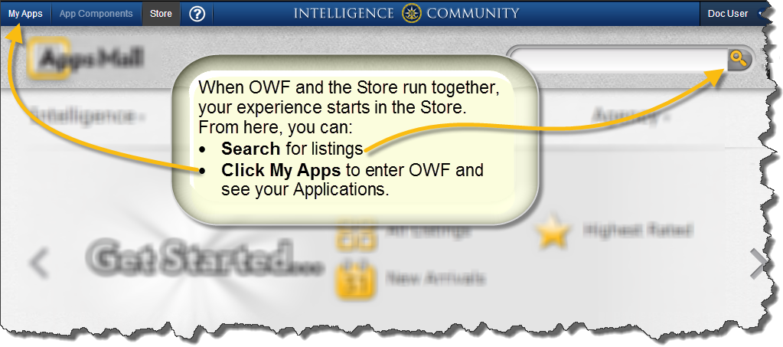

Figure : OZONE—the Store running in OWF

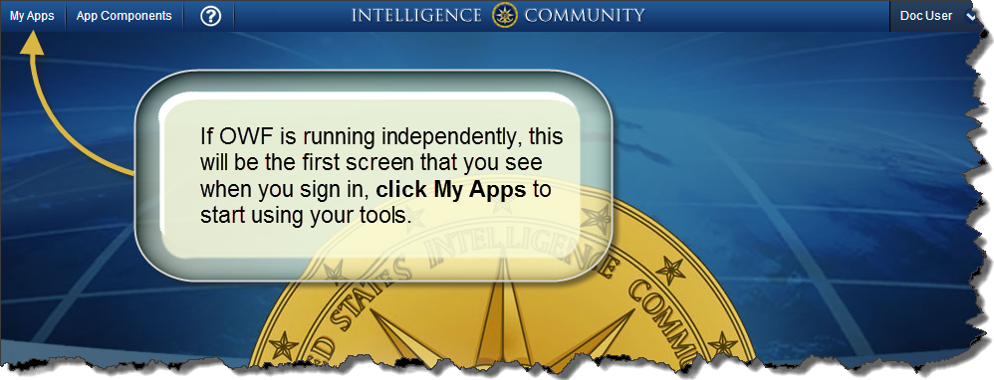

Figure : OWF without a Store

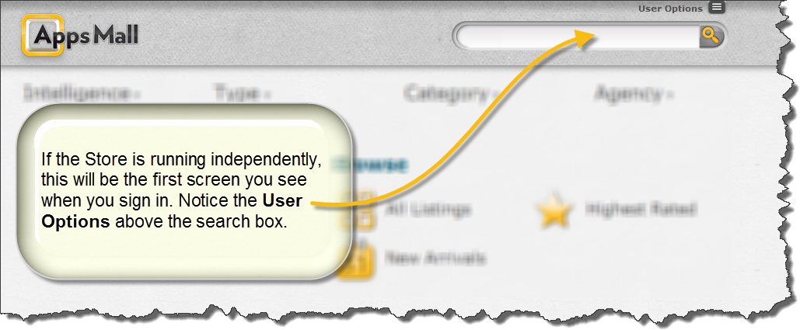

Figure : A Store without OWF

## What’s New

* Administrators can now change the agency/organization associated with a listing in the Store.
* If an approved application listing receives an update that includes unapproved app components, administrators can now move those listings into an “unapproved” state. This provides a governance mechanism to review modified listings.
* Users of standalone OWFs can now share Apps.
* The team improved the appearance and easy-of-use for the Listing Quick View and updated tooltip definitions for categories in the Store.

## Objectives

The Store, similar to a commercial application store like Apple’s App Store or the Chrome Store, operates as a thin-client registry of applications and services. It enables users to create, browse, download and use a variety of applications or software components that are known as listings. Like commercial software stores, the Store offers quick, easy access to a variety of software.

OWF operates as a framework that allows users to create custom layouts and workflows for the listings that they acquire from the Store or an administrator. The framework allows information from different agencies and servers to communicate inside a browser window without sending information back to the respective systems.

While both products can operate separately, using them together provides users with one location for everything they need to do their jobs, from searching and discovering new tools, to starting and managing those tools or building their own workflows.

## Document Scope

The document describes the tools and features available to all OZONE users. Since OZONE comprises OWF and the Store, each section denotes where the subject matter exists in the system, i.e. Listings (Store), Applications (OWF), etc.

Note: Administrative tools and features are described in the Administrators’ Guides.

## Related Documents Table

Table : Related Documents

|  |  |
| --- | --- |
| Document | Purpose |
| Administrator’s Guide | Understanding **administrative tools** and **configuration pages**: adding, deleting, and editing application components, users, groups, applications, listings, listing metadata like types, states, categories, custom fields, etc; **creating default content** for users, groups and applications; **importing/exporting** data, adding Affiliate Stores, **approving Listings**; changing Scorecard questions and weighting |
| Build Instructions | Understanding how to build the application from source code |
| Configuration Guide | Overview of **basic architecture and security**; **installation and upgrade** instructions; instructions for modifying default settings; **database** set up and logging guidance; **framework and theme** customization instructions; directions for adding and deleting **help** content; overviews of data guard and sync between OWF and the Store |
| Developer’s Guide | **Creating application components and integrating existing applications into OWF**; application component upgrade instructions; walkthroughs for creating application components; adding the following elements to application components: intents, descriptor URLs, preference API; logging and launching API; **REST Calls** and interacting with **external service items** in the Store |
| Release Notes | An overview of the **latest features** in the application |
| Quick Start Guide | **Setting Up** an integrated Store, Webtop and Metric Service |
| User’s Guide | Understanding the **user interface**; creating and searching for **listings**; adding, deleting, modifying **application components** and using **intents**; accessing and using the **Store** and **Affiliated Stores**; creating, deleting, adding, switching, modifying **applications**; defining accessibility features such as **high-contrast themes** |

## Requirements

The Store supports Internet Explorer 7 and higher, Firefox 17 and higher, and Chrome 25 and higher. It is tested against the following browsers:

Table : Tested Browsers

|  |  |
| --- | --- |
| Browsers | Versions |
| Internet Explorer | 7 & 9 |
| Firefox | 17 |
| Chrome | 25 |

Note: For optimal viewing, the Store requires a resolution setting of 1024 x768 or higher.

# Getting Started

This section provides a brief overview of the main features and functions in OZONE. You can find more details about each topic in later sections, use this section to obtain a basic understanding of the software.

## First Time Experience

When you sign in for the first time, an overlay directs you to tutorial videos and the Discovery Page. To disable the feature, check the box in the “Do not show help tips again” window:

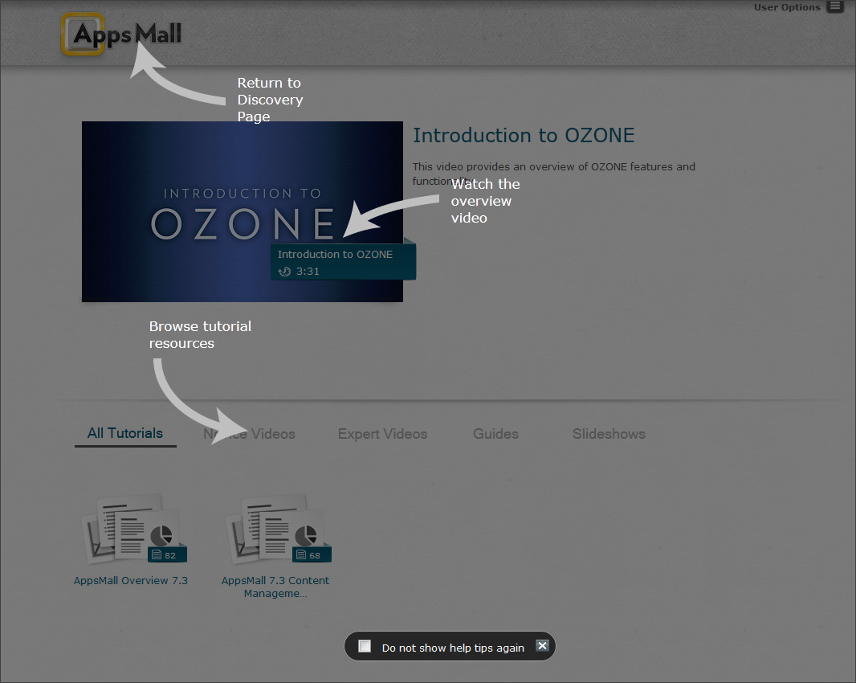

Table : First Time User Experience

Note: The overlay may not display correctly if the Store is not displayed in a full-screen view.

Note: If your instance of OZONE does not include a Store, you will see an empty OWF Application; see section 5.2: My Apps Menu to learn how to find your tools and start working.

## Use OWF and the Store

When the Store is used inside OWF the product is called OZONE. Both products can be used independently. The following section explains how each product functions. When used together, use the Store button on the OWF Toolbar to toggle between them.

### OWF Overview

A framework that allows information from different agencies and servers to communicate inside a browser window without sending information back to the respective servers.

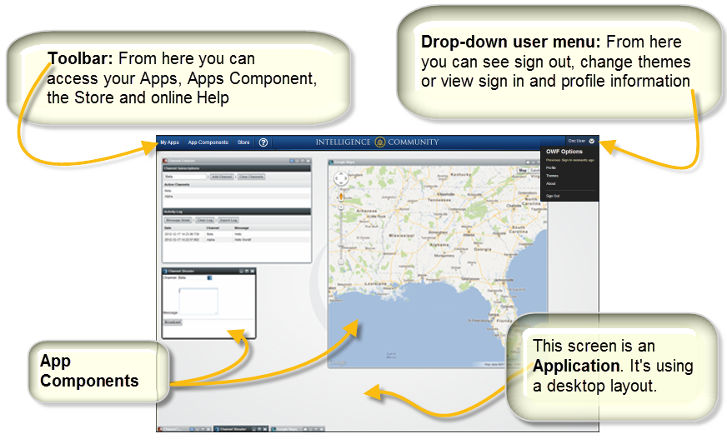

Figure : OWF at a Glance

### Store Overview

Like Apple’s App Store or the Chrome Store, the Store houses a variety of tools. From there, you can search and add them to your instance of OWF.

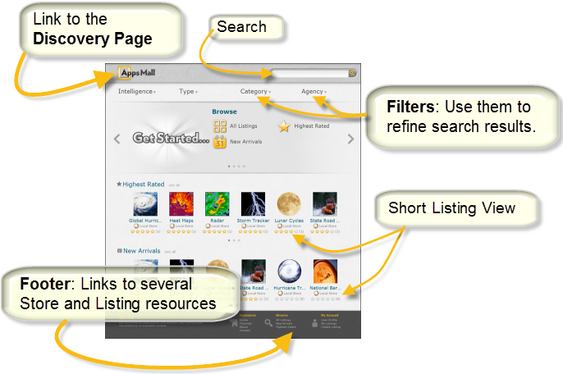

Figure : The Store at a Glance

## Product Components

### OZONE Banner (OWF)

From the OZONE Toolbar, users can open application components and applications, connect to a Store (if configured), adjust settings and open Online Help. The OWF drop-down User Menu, located on the right, displays the last sign-in date, profile information, theme options, sign-out option and About OWF window. If you’re in the Store, its drop-down menu will appear right of the OWF menu. From there, Store users can edit their profiles, change themes, view their listings and create a new listing.

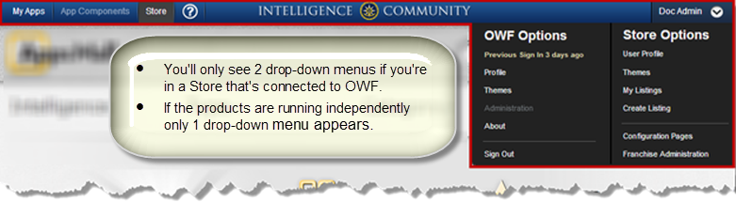

Figure : OZONE Banner

#### Toolbar (OWF)



Figure : Toolbar

The following buttons are found on the toolbar:

*  - **My Apps:** Opens the My Apps Menu used to find, start and manage applications. Use the menu to get details about an applications and application pages, discover new applications in the Store and access the App Builder. For more information about the My Apps Menu, see section 5.2: My Apps Menu.
*  - **App Components:** The App Components window displays all available application components. Use this feature to start or add components to an application. For more information see section 7.2: App Component Menu.

Note: There is a memory-based issue with opening JavaScript heavy app components in some versions of Internet Explorer. Please see Known Issues for more details.

*  - **Store:** Connects the user to a Store or Stores. When launched, a user can search from an assortment of available listings and add any of those listings to their App Components Menu see section 5.2: My Apps Menu (OWF). See section3.2.2: Search Options for more details about finding listings in the Store.

Note: The Store button will only appear in the toolbar if it has been configured by a system administrator.

*  - **Online Help**:Repository of instructional guides and video tutorials.

#### Drop-down User Menu (OWF)

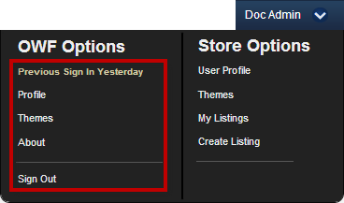

Figure : OWF Drop-down User Menu Options

Access the drop-down User Menu by clicking on the username in the upper-right of the page. The following elements reside in the OWF User Menu:

* **Last Sign In –** Text displaying the approximate time the user last entered OWF.
* **Profile –** User identification including the username, full name, e-mail and list of groups of which the user is a member. Under the User Preferences heading, the user can also enable OWF animations by clicking the “Enable animations” checkbox.  
  Note: Enabling animations may cause issues with third-party plug-ins like Google Earth.
* **Themes** – Opens the Theme Settings window. Find more information about themes in section 8.2: Change themes.
* **About –** Displays customizable information about the product.
* **Sign out –** Used to sign out of the framework in accordance with the security protocols that were used for the initial sign-in.   
  Note: This feature is configurable by an administrator and may not appear on some versions of OWF.

#### Drop-down User Menu (Store)

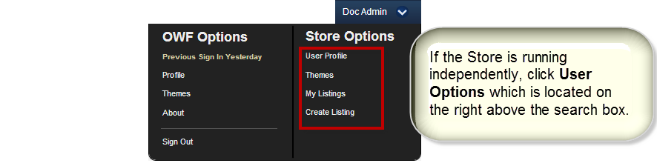

Figure : Store Drop-Down User Menu Options

When a user accesses a Store in OWF and opens the User Menu, two user menus will appear. The right menu is the Store User Menu.

Note: If the store is not running inside an OWF, only Store Options will appear on the drop-down User Menu.

The following elements reside under the Store User Menu Options:

* **User Profile** – Users can edit their profile, view their e-mail address or enable Store animations by clicking the “Enable animations” checkbox under the User Preferences tab.
* **Themes** – Allows the user to change the Store theme see 8.2.1: Themes (Store).
* **My Listings** – Displays the user’s recent activity. Also lists non-approved and approved Store listings.
* **Create Listing** – Allows the user to create a new Store listing. More information about the Store User Menu elements is found in section 4: Listings: Add, Create, Review (Store).

### Discovery Page (Store)

The Discovery Page is the homepage for the Store. It’s the first page you’ll see when you enter the Store or when you enter OZONE if OWF is connected to a Store.

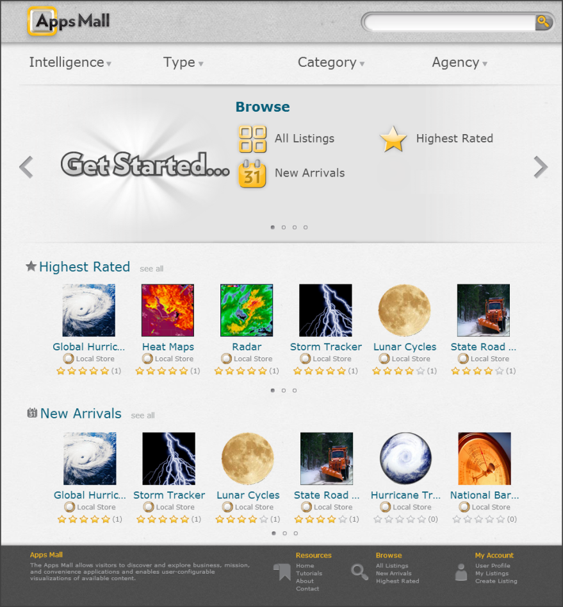

Figure : The Discovery Page

From the Discovery Page you’ll see:

* Approved listings sorted by rating and arrival time. Find more information about listings in section 4: Listings: Add, Create, Review (Store).
* The **Get Started Carousel** at the top of the page which links to specific groups of listings and training materials.
  + Click the right or left arrow on the carousel to use the other panes.
  + Navigate to these panes by clicking on any of the dots at the bottom of the carousel or the left or right arrows, see Figure 11:

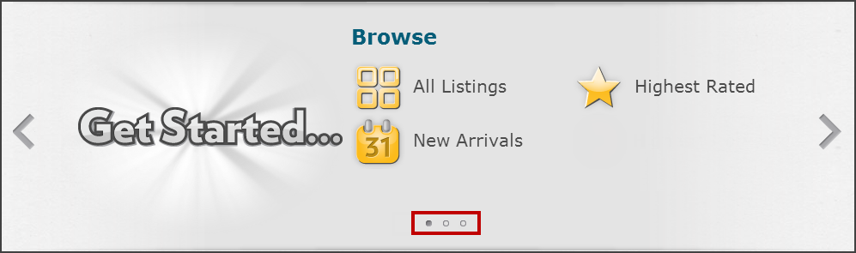

Figure : Pane Navigation on "Get Started" Carousel

Below the “Get Started” Carousel are two carousels: Highest Rated and New Arrivals.

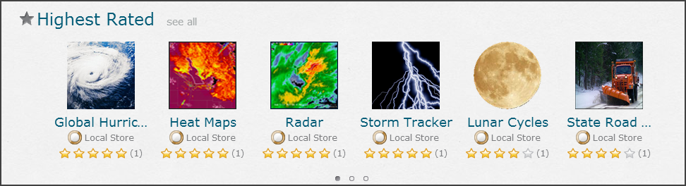

Figure : List Carousel on the Discovery Page

To the right of each carousel’s title is a  link. When clicked, a Search Results page will show all the listings that meet that filter’s search criterion. Listings on this Search Results page can be filtered further to refine the listings. Find more information on filtering listings in section 3.2.2.1: Filters.

## Footer (Store)

The bottom portion of the Store is called the footer.



Figure : The Footer

This includes several options for quick navigation and search. Navigation is split into three categories with the following options:

**Resources**

* **Home** – Directs the user to the Store’s Discovery Page.
* **Tutorials** – Direct users to the Store’s training materials.
* **About** – A pop-up window with information about the Store and build information.
* **Contact** – Launches the user’s default e-mail client, allowing them to contact support, provided it has been configured by an administrator.

**Browse**

* **All Listings** – Navigates to a Search Results page that contains all listings.
* **New Arrivals** – Navigates to a Search Results page allowing users to browse the newest listings.
* **Highest Rated** – Navigates to a Search Results page that arranges listings by the highest star rating in descending order.

**My Account**

* **User Profile** – Navigates to their Store profile.
* **My Listings** – Launches the My Listings page which displays the user’s listings.
* **Create Listing** – Launches the Create Listing page.

# Search & Discovery (Store)

## Overview of Search

OZONE allows you to search its Store, your Apps and App Components. The following sections will explain how to use each search. While OWF provides some search capability, searching is one of the main aspects of the Store.

## Search for Listings (Store)

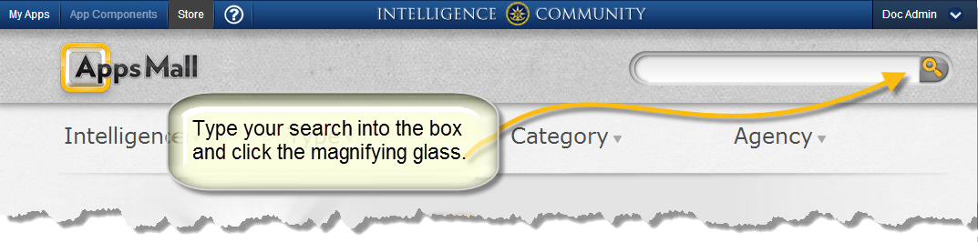

The Store returns search results in the following order:

1. The first factor that influences search results is the search query, i.e. the term that you use to search or your “search term.” The Store will return the listing that best matches your search term first, followed by the listing that second best matches your search term and so on.   
   Note: If you click search without entering a search term, the primary order of results will be the listings’ Lucene score in descending order for more information about Lucene searches see 3.3: Expanded Explanation of Search.
2. The secondary order that search results are returned is by rating (the stars) in descending order.
3. The tertiary order that search results are returned is by title alphabetically in ascending order.

Search results can change based on filters, see section 3.2.2.2: How filters change Search Results.

### Search Affiliated Stores (Store)

If a Store is configured to see search results from Affiliated Stores, results from each external store appear in carousels below the local store’s search results. The results from the Affiliated Stores look like the results returned from the local store. However, users cannot add feedback to the Affiliated Store listings. Also, if a user filters search results by Type, Category, etc., affiliated search results will not display.

The first six search results from each Affiliated Store will display on the search results page. If an Affiliated Store returns more than six results, click the pagination dots below the listings to navigate to additional results.

If more than 30 listings in the Affiliated Store match the search criteria or you want to see all of the Affiliated Store’s search results, click the "see more" link adjacent to the Affiliated Store's name. This will open a full-page view of the Affiliated Store’s search results.

Note: A valid certificate is required for each Affiliated Store that you search, in order for listings to be shared between stores. Also, to add app components from an Affiliated Store to OWF, an OWF Administrator must have configured the Affiliated Store as an app component in OWF and sync must be enabled.

Note: Find instructions about configuring Affiliated Stores in the Store Administrator’s Guide.

### Search Options (Store)

#### Filters (Store)

Filters reduce search results by type, category or agency.

On the Discovery Page and Search Results pages in the Store, the Navigation Menu bar appears directly below the toolbar. (Click the Store’s logo in the upper-left corner of every page to return to the Discovery Page.) To show all of the filtering options, hover over the filter. All the options will appear, as shown below:

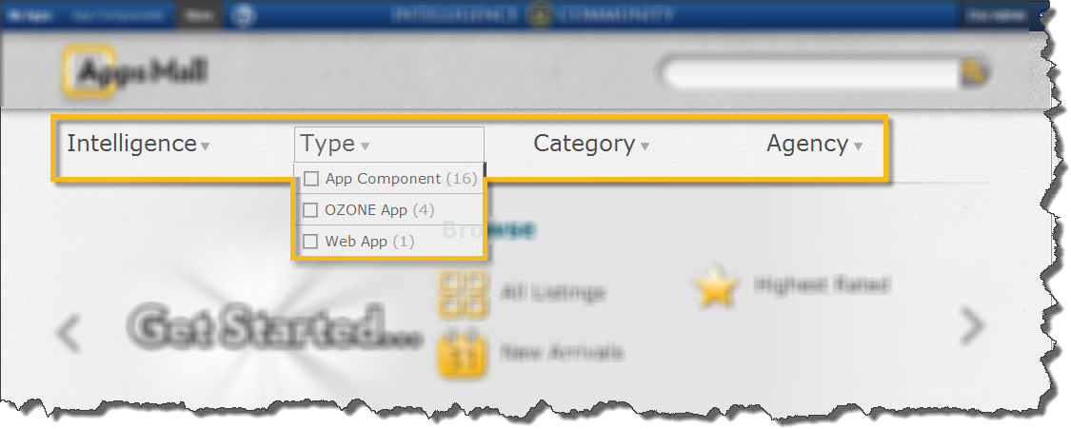

Figure : Filters

To select an option, click the checkbox located on its left. The system will automatically refine the search results to only display listings that meet the filter criteria.

#### How filters change Search Results (Store)

After an initial search, you can modify the appearance of the results by filtering or sorting. Sorting replaces the primary order of the search rules. The secondary order that search results are returned is by rating (the stars) in a descending order. The tertiary order that search results are returned is by title alphabetically in ascending order.

Example: When you sort your results by approval date (the calendar icon ) - your search order will be date, then rating, then title.

Note: When filtering, the store continues to use the existing sorting order that was returned for the previous search term.

#### Sort Icons (Store)

This section describes the icons used to filter listings on the Store’s Search Results Page.

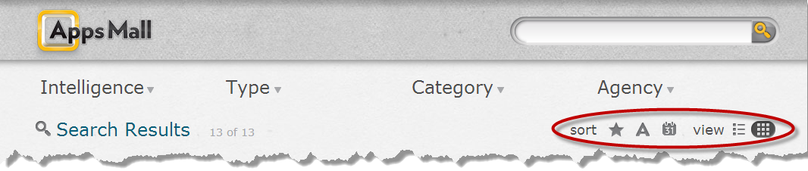

Figure : View & Filter Icons

Use the  and  buttons at the top of the page to select a grid or list view, respectively. When using the list view, the listing’s description is displayed. Select the following icons to further sort the Store listings:

 - Sort listings based on user ratings

 - Sort listings alphabetically based on listing name

 - Sort listings based on release date

Clicking an icon for the second time will reverse the sorting.

### Search from the Browser (Independent Store)

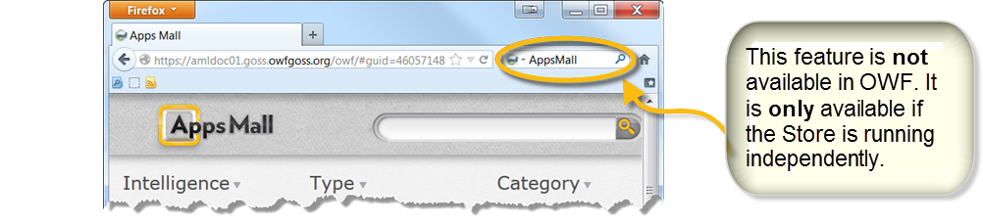

Figure : Search from the Browser

If the Store is running independently, it supports OpenSearch technology. This feature is NOT available if the Store is running as part of OWF. OpenSearch is a collection of simple formats that share search results. It helps search engines and search clients communicate and syndicate search results through a common set of formats that perform search requests. It publishes results in syndicated and aggregated formats like ATOM and RSS.

When added to a browser, the Store-specific search appears as a drop-down search choice (shown below in Firefox.) Any words entered into a Store-specific search will only search that store, and not the entire Internet.

Searching from the browser returns the same results as a search in the application. The advantage of initiating a search from the browser is that a user can bypass the homepage and jump directly to their search results. This search is powered by a Lucene™-based index which enables extremely specific searches.

### Search Results Display Options (Store)

In the Store, the Search Results page appears after a user selects a filter via the Navigation Menu bar or after performing a text search. Initially, the Search Results page displays listings in Grid view, with a ‘tile’ for each listing. The Grid view displays listings’ store, rating and Scorecard fields.

To view the Search Results page listings in List view, click the  icon in the upper-right corner of the Search Result page.

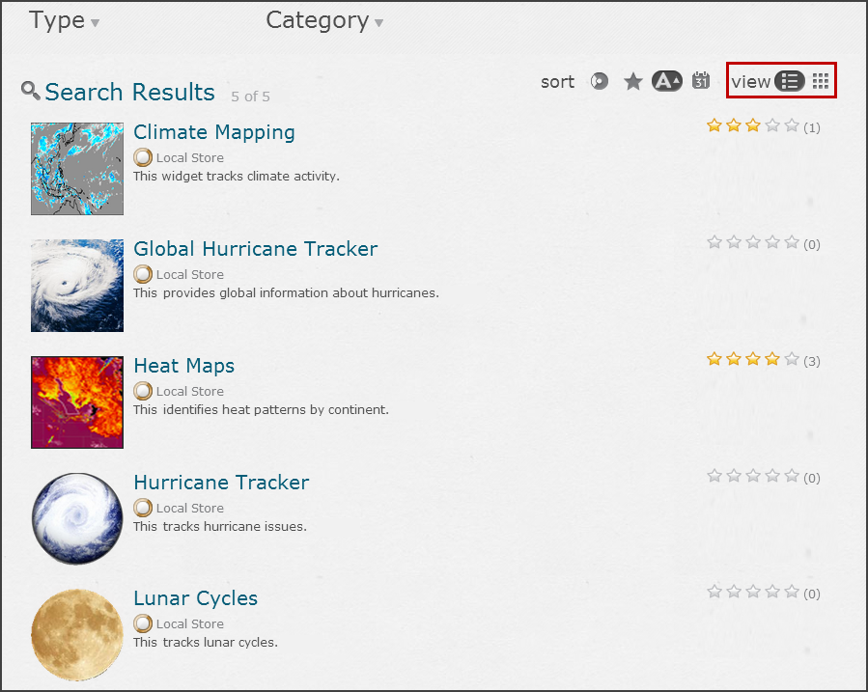

Figure : Search Results – List View

## Expanded Explanation of Search (Store)

Searches in the Store are powered by a Lucene™-based index that is built on [elasticsearch](http://www.elasticsearch.org/) capabilities that enable detailed search functionality. You’ll find specific Lucene search terms in Table 6: Search Criteria.

Lucene Scoring bases its score on the frequency a query term appears in a listing relative to the number of times the term appears in all listing.

Developers can influence these results by “boosting” the importance of matching search results to some fields. The Store does this by boosting the importance of agency name, title, description, requirements and dependencies (in descending order of boost value).

Note: In older versions of the Store, the listing’s title was not “boosted” enough to substantially affect its rank in search results.

Here is how the above rules translate into behavior of certain initial searches done in the store:

Table : Explanation of Search Results Order

| Search Description | Result |
| --- | --- |
| Type a search term into the search box and press enter. | The store will return search results sorted in the following order:   1. Score 2. Rating 3. Title |
| Leave the search box blank and click the magnifying glass icon (or placing the focus in the box and pressing enter). | The store will return search results sorted in the following order:   1. Score 2. Rating 3. Title   However, since there is no term to score, all listing will have the same score. Therefore sorting will actually appear to be rating first and title second. |
| Click the "All Listings" link on the Discovery Page. | This passes a sort and order parameter in the request (title, ascending) - so results will be sorted in the following order:   1. Title 2. Rating |

It is possible that hits in other boosted fields (e.g. description) could rank listings higher than hits ranked by title if those other fields favor the terms heavily. There are a few ways to address this:

* Make an exact match on title the highest ranking result - this would involve restructuring the current query into a compound query where the search string is first considered as a whole before being split up into separate search terms. A result on an exact match in the title field would be boosted to a higher score than other matches.
* Structure the query so that boosted fields are queried/scored separately - this would heavily favor the title field without making it necessary that you have an exact match to see the listing high in the rankings. Examples:
  + Targeting App Component would score high on a query for target app component
  + Listing Title title Results by listing title title of listing
  + Outside Flag isOutside Results by listing visibility true or false

## Additional Search Information (Store)

Things that affect search results:

* Approval Status: a regular user (not an administrator) only sees
  + listing that have been approved
  + any listings they own
* Inside/Outside: local searches of a store will return both inside and outside listings. An affiliated search will return only outside listings.
* String search criteria must be enclosed in quotes if there are embedded spaces, for example: “My App”

## Lucene index search terms (Store)

The following table will provide instructions for users who want to conduct extremely specific searches. These terms are based on the Store fields used in the Lucene indexes. For instruction on Lucene-based query delimiters (i.e. wildcards, etc.) see the [Lucene](http://lucene.apache.org/core/3_6_1/queryparsersyntax.html) documentation.

To perform a detailed search, enter a search term from the following table in the Search Window followed by a colon and the search criteria. For example, to search for listings that are pending, enter: **approvalStatus:Pending**

The following examples use the extremely specific searchs:

* Compound conditions are connected with AND/OR operators. For example, isOutside:true AND types.title:"App Component" returns all app components that are visible to those outside the store.
* Parenthesis are used to group conditions. For example, NOT( isOutside:true AND approvalStatus:Approved) returns all types that are not approved or that are not visible to the outside.

Table : Search Criteria

| Apps Mall Name | Search term | Description of search criteria | Search criteria |
| --- | --- | --- | --- |
| Approval status | approvalStatus | Results by status | Approved, “In Progress”, Pending |
| Date approved | approvedDate | Results by approval date | date in the following format: yyyyMMdd'T'HHmmss.SSSZ |
| Average rating | avgRate | Results by average rating | numeric |
| Categories | categories.title | Results by category title | category name |
| Comments | itemComments.text | Results by comment | a word within the comment text |
| Comment Total | totalComments | Results by the number of assigned comments | Numeric |
| Date of last activity | lastActivityDate | Results by the date of last activity | Date in the following format: "yyyyMMdd  HH:mm"  *Note: Two spaces between day field and hour field* |
| Enable/Disable | isHidden | Results by the enable/disable feature | 0 or 1 |
| Organization | organization | Results by the owners’ organizations | a word in the organization name |
| OWF Background Properties | owfProperties.background | Results by the Background field | true or false |
| OWF Singleton Properties | owfProperties.singleton | Results by the Singleton field | true or false |
| OWF Visible in Launch Properties | owfProperties.visibleInLaunch | Results by the Visible in Launch field | true or false |
| Owners’ display names | owners.displayName | Results by owners’ name | owners’ first or last name |
| Owners’ username | owners.username | Results by owners’ username | owners’ complete username |
| Release date | releaseDate | Results by the release date | "yyyyMMdd" |
| State | state.title | Results by state | name of state |
| Technical point-of-contacts | techPocs | Results by technical POC | value entered in the Technical POC fields |
| Total Votes | totalVotes | Results by the number of users that rated the listing | Numeric |
| Types | types.title | Results by type | name of type |
| URL (for documentation) | docUrl | Results by documentation URL value | full URL in quotes |
| URL (for installation) | InstallUrl | Results by installation URL value | full URL in quotes |
| URL (for launch) | launchUrl | Results by launch URL value | full URL in quotes |
| URL (Large Image) | imageLargeUrl | Results by large image URL value | full URL in quotes |
| URL (Small Image) | imageSmallUrl | Results by small image URL value | full URL in quotes |
| URL (screenshot1) | screenshot1Url | Results by screenshot URL value | full URL in quotes |
| URL (screenshot2) | screenshot2Url | Results by screenshot URL value | full URL in quotes |
| Version Name | versionName | Results by version name | value entered for version (usually numeric) |

# Listings: Add, Create, Review (Store)

## Listing Overview (Store)

Listings on the Discovery Page and the Search Results page appear in their Short Listing View. To see more listing information, click the listing’s title, image or rating to open the Quick Listing View. The following sections describe all the listing views and the features they include.

## Listing views (Store)

### Short Listing View (Store)

The short listing view provides users with basic information about the listing. Listing details included in the short listing view are the listing’s name, icon, originating store and ratings which are described below.

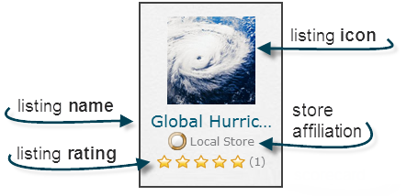

Figure : Short Listing View

Listings organized in carousels on the Discovery Page and listed on the Search Results page appear in short listing view. The Short Listing elements include:

* **Listing icon** — Click the listing icon to launch the Quick Listing View. See section 4.2.2: Quick Listing View for more details.
* **Listing name** — If the listing name is too long to fit under the listing icon, it will end with an ellipsis (…). The full name can be viewed by hovering over the listing name. Click the listing name to launch the Quick Listing View. See section 4.2.2: Quick Listing View for more details.
* **Listing’s rating** — The rating of the listing and total number of votes cast is displayed under the listing name. The rating is read-only and votes cannot be cast from this page. To rate a particular listing, you must first click the listing and view it in the Quick Listing View. See section4.2.2: Quick Listing View for more details.
* **Store Affiliation** – If configured, mulitple agencies can enter listings into the Store. A listing’s affiliation will appear below its name.

### Quick Listing View (Store)

The Quick Listing View starts when a user clicks a Short Listing View from the Discovery Page or a search results page.

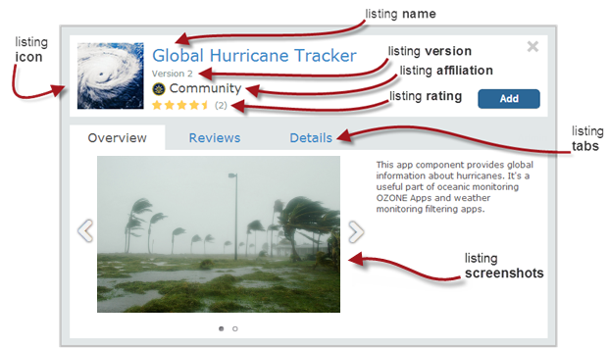

Figure : Quick Listing View

The Quick Listing View includes all the elements from the Short Listing View (listing icon, name rating and store affiliation) as well as:

* **Listing version** – This field identifies the version associated with the listing.
* **Listing description** – A description of the listing appears on the Overview tab.
* **Listing screenshots** – If the listing includes screenshots, they appear on the Overview tab. If there are multiple screenshot, use the left/right arrows or the dots below the images to scroll from one image to the next. Click the image for an expanded view.
* **Scorecard compliance** – If an administrator enabled the scorecard icons, any icon that corresponds with compliance criteria that the listing meets will appear on the Overview tab.
* **Listing Overview** – A description of the listing provided by the owner or an administrator .
* **Listing Reviews** – User comments and ratings about the listing. See section 4.4: Review Listings.
* **Listing Details** – Information about the listing’s type, categories, owner, requirements, etc. See section 4.2.2.1:Listing Details.
* When the listing opens, its Overview tab appears. To see reviews or details, click the respective tab.

#### Listing Details (Store)

The Details tab shows the listing specifications and requirements. If a listing does not include a field, it will not appear on the Details tab.

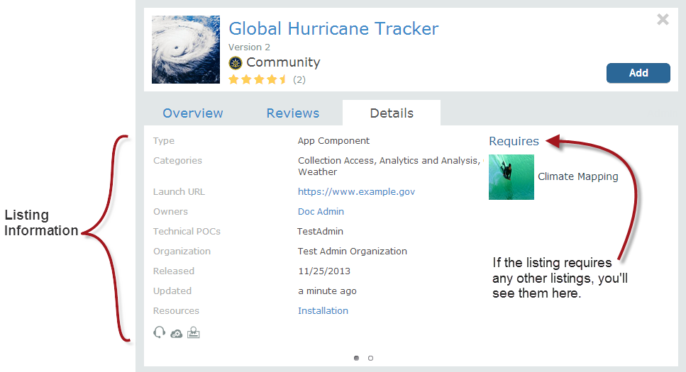

Figure : Details Tab

This tab can include information about:

* Listing requirements and dependencies
* Association with organization, technical point of contact, listing owner
* Modified date
* Type-specific listing information

### Detailed Listing View (Store)

Only **listing owners** and **administrators** will see the Detailed Listing View. It is accessible by clicking “Admin” on the Quick Listing view. This action automatically opens a new page displaying all the listing’s detailed information. For more information, see the Detailed Listing Page section of the Store Administrator’s Guide.

Note: The Store provides links to identified applications. Access controls and application operation are the responsibility of application owners.

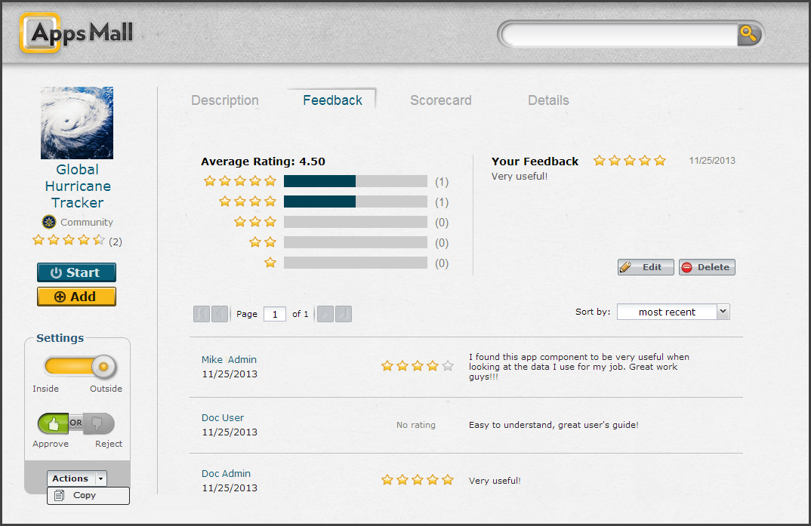

Figure : Feedback Tab on Detailed Listing Page

### My Listings Page (Store)

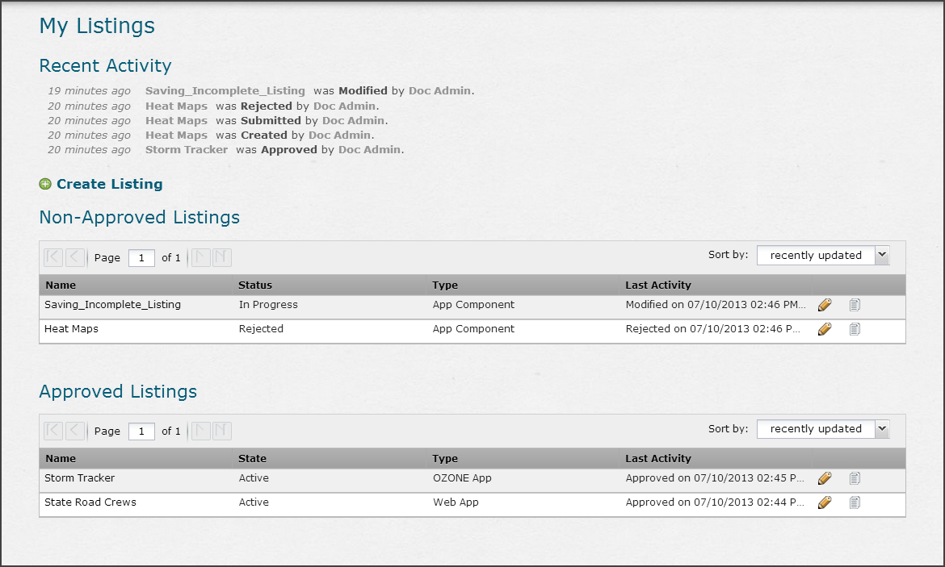

Figure : Main View/My Listings Page

Us the My Listings Page to look at all of your listings and recent activity in the system. Accessible from the drop-down User Menu, the My Listings page comprises three main sections:

* **Recent Activity** – lists information on the last five actions which were taken on any of the listings that the user owns.
* **Non-Approved Listings** – Provides listing information about all of the user’s pending and rejected listings. These listings do **NOT** appear in the Store’s search results.
* **Approved Listings** – Provides listing information about all of the user’s approved listings. These listings appear in the Store’s search results.

Additional tools on the My Listings page are the Edit and Copy tools accessible from the icons shown in Figure 23 below. Clicking the Copy tool opens up the Create New Listing page with the listings information pre-populated in the new listing fields. Clicking the Edit icon allows the user to edit the listing’s information and then save the changes.



Figure : Edit/Copy Icons

Lastly, users can create a new listing from the My Listings page. To do this, click the  button. This will bring the user to the Create New Listing page. More information on creating listings is found in section 4.5: Create Listings (Store.

#### My Listings Page Terms (Store)

The following terms are used in the My Listings page in the Store:

* **Submitted** — The owner submitted the listing for administrator approval.
* **Rejected** — An administrator rejected the listing.
* **Modified** — An owner or administrator of the saved listing modified it.
* **Created** — Refers to the first time the listing was saved.
* **Approved** — An administrator approved the listing.
* **Enabled —** An administrator or owner enabled a listing.
* **Disabled** — An administrator or owner disables a listing.
* **Inside** — An administrator makes a listing visible to users inside the Store.
* **Outside** — An administrator makes a listing visible to other Stores.

To learn how “required” and “required by” listings appear in the “My Listings” pane, see section 4.7.1.2: Required Listings in the Change Log and My Listings. The “My Listings” page contains two paginated tables showing a maximum of five non-approved listings and 10 approved listings per page.

## Add Listings to OWF (Store)

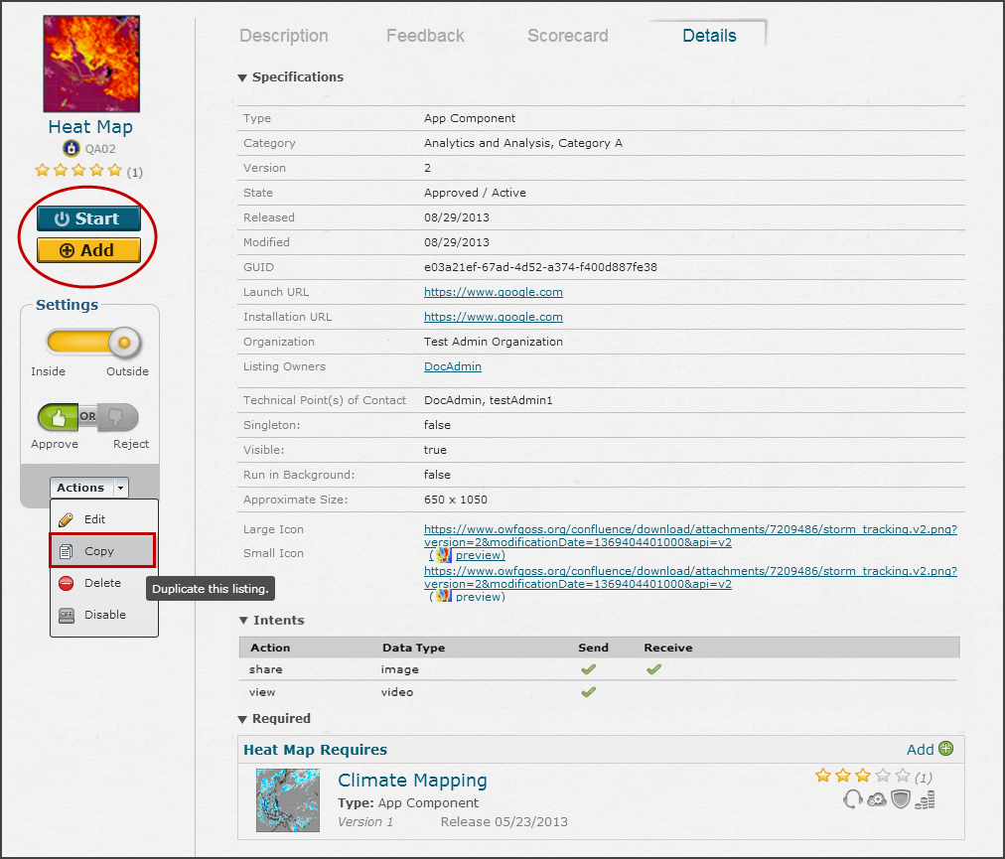

Figure : Actions Drop-down and Start/Add buttons

Users can **Start** a listing or **Add** it to OWF by clicking the corresponding buttons on the left navigation panel.

* **Start** – Opens the listing.
  + If the Store is used within OWF, an Application or Web App will open on a new Application screen. To navigate back to the Store, click the Store button on the Toolbar at the top of the screen. To navigate to a different Application, click the My App button. If the listing is an app component, start will open it on the last application you used before entering the Store.

The Store does not dictate or ensure the functionality of a listing. Proper functionality of a particular listing is the responsibility of the approving administrator and the listing owner.   
Note: This choice will only appear in the left-navigational panel if the listing is approved, its state is publishable (The administrator who created the state set publish to true.) and it has a launch URL.

* **Add** – Adds the listing to the user’s App Components or Applications in OWF. This option only appears if the store is associated with an instance of OWF.   
  If the listing is an application, clicking Add moves a copy of it and its app components to your instance of OWF. They’re respectively accessible from the My Apps and App Components buttons on the toolbar.   
  Note: Not all listings can be added to OWF. The Listing Type must have a launch URL, icons and be OWF Enabled.

### Start/Add a Web App (Store)

When you start a web app in the Store it is added to OWF as an application. To navigate to it in OWF, click My Apps on the Toolbar and Select its name. If you are not connected to an OWF, the web app will start in a new browser tab.

## Review Listings (Store)

The following image overviews the Reviews tab on a Quick Listing View.

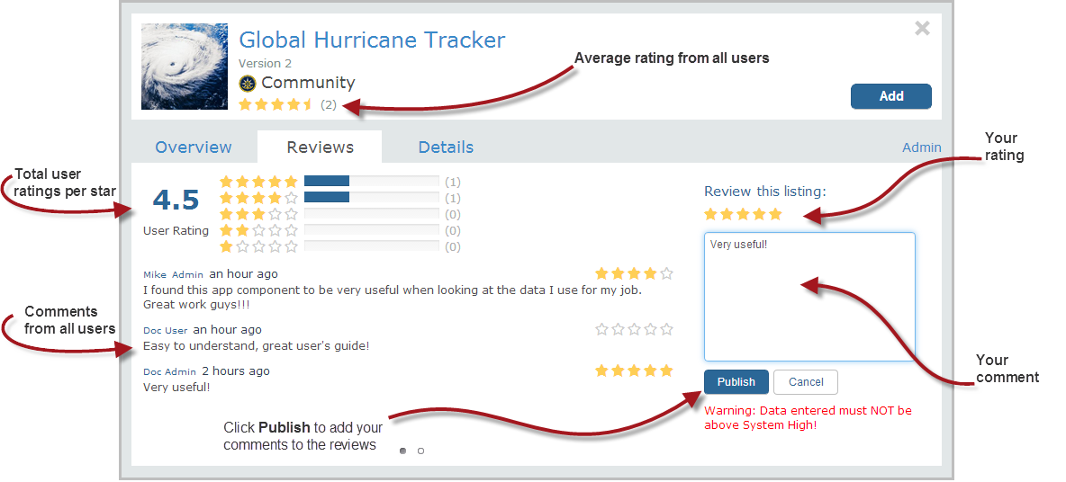

Figure : Reviews/Feedback Tab

The Reviews/Feedback tab:

* Displays the listing’s average star rating and all user feedback
* Provides a mechanism for leaving user feedback.
* Clicking the row of a specific comment takes you to the profile of the comment’s author. Users have the ability to edit or delete their own comments using the Publish and Cancel buttons.

Note: Administrators have edit/delete privileges for all comments.

### Add Comments (Store)

From the Review tab on the Quick Listing view shown below, a user can view comments associated with a listing. Users can add a comment by selecting the tab and entering a 250-character comment related to their experience with the listing. See the image below for details.

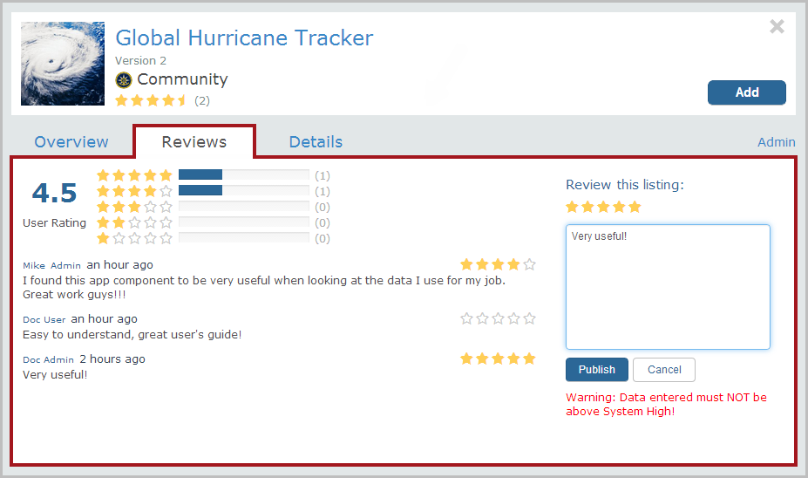

Figure : Adding Feedback

A user can edit their existing comment by clicking in the text box and then, clicking Publish.

Note: Administrators have edit/delete privileges for all comment.

### Add Ratings (Store)

Users have the ability to rate listings. Future users can use the rating to gauge the popularity of that listing:

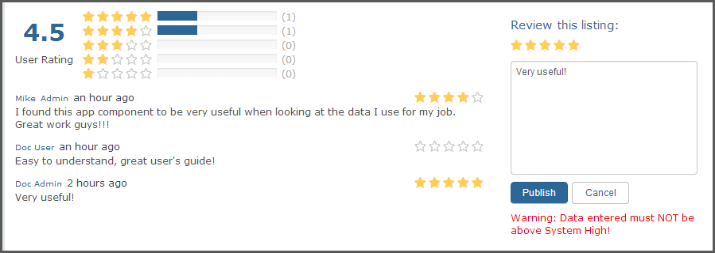

Figure : Rating a Listing

 – The numbers of stars shows the user’s ratings for a listing.

– The number of listings for each starred rating.

## Create Listings (Store)

### Walkthrough: Create a Listing (Store)

Any software application or component that a user enters into the Store is called a “Listing.” Listings can be various types of Web content.

This section explains how to create a Listing:

1. Start by clicking “Create Listings” from one of three places: the drop-down User Menu in the toolbar; the My Listings page or in the Footer at the bottom of the page.

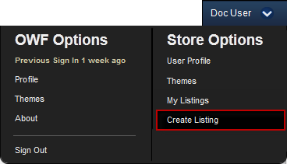

Figure : Create Listings

1. This opens the Create Listing modal:

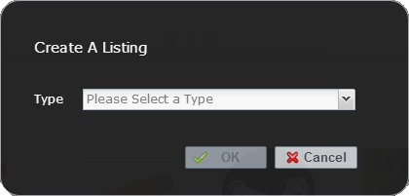

Figure : Create Listing Modal

Use the drop-down menu to select the type of listing to create and click OK. The store includes three default types:

* **App Component** — A lightweight, single-purpose application that offers a summary or limited view of a larger application. After OWF users add an App Component from the store, they can add it to an Application, see 7.3: Start App Components (OWF).
* **OZONE App** — A collection of App Components (previously called widgets) arranged in specific layouts. To create an OZONE App, first export it from OWF and then upload the HTML file to the Store and continue to step 3. When a user adds an OZONE App from the store, it will appear in My Apps on their OWF Toolbar.
* **Web App** — A program that cannot interact with other App Components. Web Apps automatically open as their own OZONE App. When a user starts a Web App from the store, it will appear in My Apps on their Toolbar.

Note: An administrator can add any listing Type to the drop-down list.

1. After choosing the listing type, the “New Listing” page will launch. Every listing has some mandatory fields such as Name, Type and Owner that are identified with red asterisks. If you’re ready to submit the listing, click save and go to section4.5.3:Submit a Listing for Approval (Store).  
   If you’d like to save the listing before publishing it. See 4.5.2: Save Incomplete Listing Form for information on how to save a listing before submitting it.

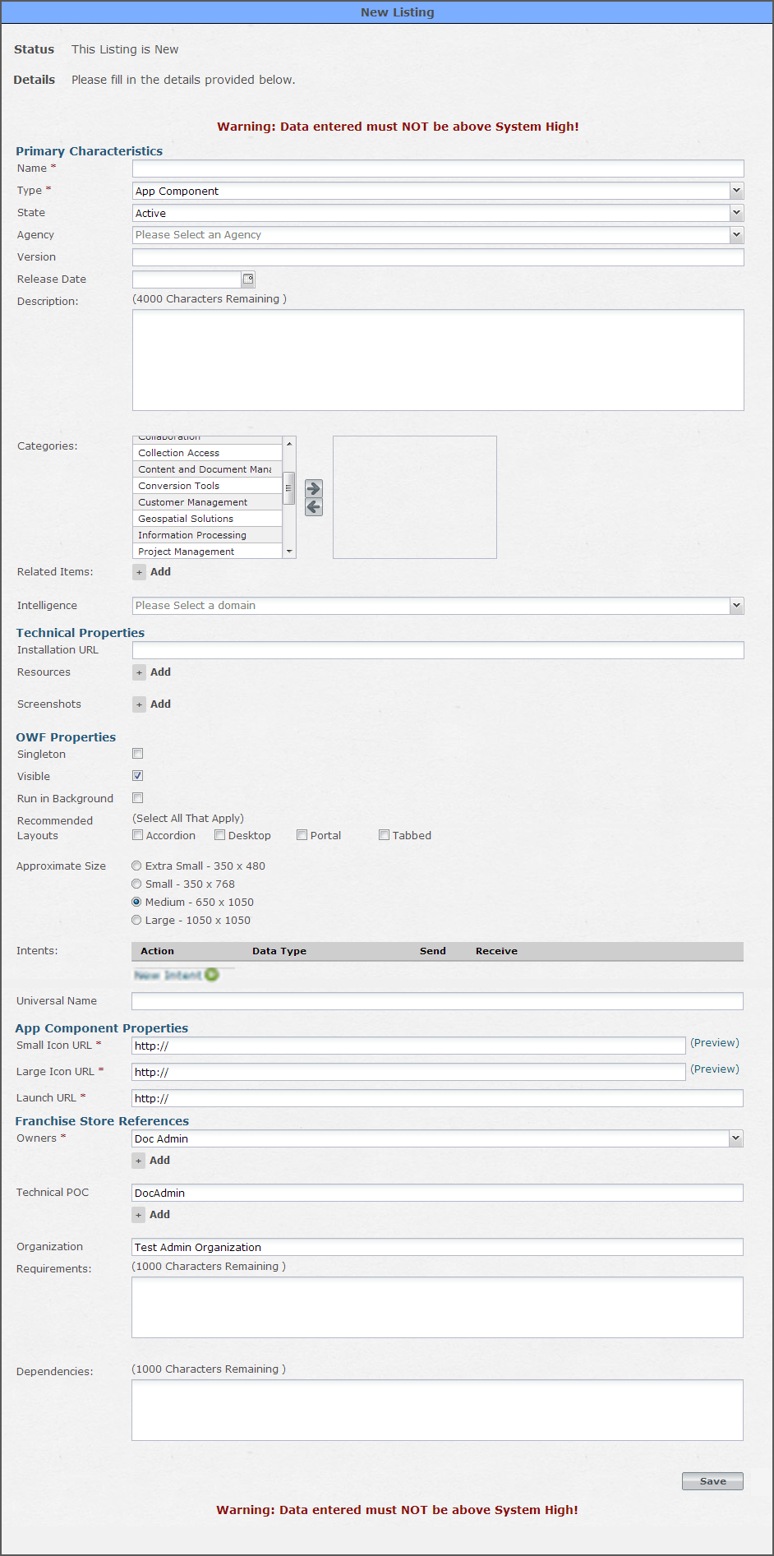

Figure : Add Listing Dialog

The fields in the Add Listing Dialog window are described below:

Note: All the fields mentioned below will **not** appear in every listing type. Also, administrators may include additional custom fields that are not defined.

* **Name** — Displays the name of the listing. Names are not required to be unique within the system.
* **GUID** — Display a unique identifier that cannot be edited. It is a searchable field. This field only appears AFTER a listing is created. It will not be visible the first time a user populates the Add Listing dialog window, which is why it is omitted from
* Figure 30.
* **Type** — Defines the listings technology (e.g. App Component, OZONE App, Web App, etc.). Types can be added and removed from the Store as needed by the system administrator.
* **State —** Allows the user to assign a state (e.g. active, retired, etc.) to a listing. States can be added and removed from the Store as needed by the system administrator.
* **Version** — Displays the version number an administrator assigned.
* **Release Date** — The month/date/year in which the listing was or will be released. This is for informational purposes only.
* **Description** — To make it easier for users to determine the nature of the listing, a succinct summary should be captured in the first few lines of the description." This field can contain 4,000 characters.
* **Categories** — Displays the categories to which a listing will be associated. An administrator can add and remove categories from the Store as needed. The category groupings can be as simple as “category b” or as descriptive as “geospatial category.” A listing can be associated with multiple categories.  
  Note: A list of standard Categories is defined in 10A.1: Glossary of Categories.
* **Domain (Intelligence)** — Displays the administrator-supplied domain categories in drop-down format. Multi-select is active and can be used to populate the field.
* **Technical Properties** 
  + **Installation URL** – Allows a user to enter various URLs which offer listing resources.
  + **Resources** – Click the + to add resources to the listing. The label will appear in the Details section of the listing, it will link to the URL provided in the Resources section.
  + **Screenshot URL** – Provide URLs for images that will be included in the Detailed section of the listing.
* **OWF Properties** — Appears when an OWF compatible type is selected.
  + **Singleton** — Designate if a listing can have only one instance launched in OWF.
  + **Visible** — Dictates if it will appear in the App Component Menu in OWF.
  + **Run in Background**— Designates if a listing should only run in the background when needed/launched by OWF.
  + **Recommended Layouts** — Suggests application layouts in OWF that complement the listing within OWF.  
    Note: If the Type has the “OWF Compatible” flag checked, a listing will be made available to an associated OWF instance. See the Administrator’s Guide for more details.
  + **Approximate Size** — The pixel size of the window where the listing will open in OWF:
    - Extra Small size = 350 x 480
    - Small size = 350 x 768
    - Medium size = 650 x 1050
    - Large size = 1050 x 1050
  + **Intents** – Use this field to add one or more intents. Find more information about adding intents in 10Appendix B: Intents: Create & Edit Dynamic Listings (Store).
  + **Stack Context** – In applicable, enter a title that will be added to the root of the OWF Instance and serve as the exact URL location for the Stack, as shown in the following example: https://www.exampleOWFinstance.com/*StackContext*
  + **Universal Name** –A value that can be used as a listing’s global identifier across all instances of OWF and Stores. This differs from a GUID which is unique to a specific installation.
* **App Component Properties** 
  + **Small Icon URL** – Address for the image that identifies the App Component on browser tabs or other small spaces
  + **Large Icon URL** – Address of the image that identifies the App Component in most places like the Detailed Listings page and default search results.
  + **Launch URL** – Location Addresses for the App Component’s launch URL and the icons that will be used to represent it in the Store as well as in OWF’s Application Builder and on a minimized tab.
* **Franchise Store References**
  + **Owner(s)** —Pre-populated by the authenticated username at the time the listing is created. Ownership can be reassigned by typing a new owner’s name in the owner field on the listing page. To add more than one listing owner, click the + button below the Owners field.
  + **Technical POC** — While the field can be populated with any “point of contact” information that the submitter wishes to enter (e.g., email, phone), it is pre-populated with the authenticated username at the time the listing is being added. To add more than one technical POC, click the + button below the field.
  + **Organization** — Will be pre-populated with the organization as set-up in the default custom security modules. However, in a production environment, the organization data will be populated from the user’s contributor profile information that is returned from the particular security module being used. For more about contributor profiles see section 8.1.1: User Profile (Store.
  + **Requirements** — Allows the user to note any software or hardware requirements the listing depends on for proper functionality.
  + **Dependencies** — Allows the user to note any additional items (such as software, operating systems or additional listings) that add to the overall functionality of the listing that is being created.
* **Custom Fields** — Administrators can associate custom fields with specific listing types. The custom fields can be text, drop-down, checkbox or image URL fields. They can appear in any section of the Create/Edit listing page and may or may not be required.   
  Note: Requiring Custom Fields may cause errors for administers who try to add listings from OWF to the Store because listings coming from OWF will not have those required custom fields.

### Save Incomplete Listing Form (Store)

When creating a listing, including incomplete listings, you must complete all the required fields associated with the listing’s type. Once completed, clicking  will create the listing and mark its status as “in progress.” At this point, the listing is saved but not submitted for administrator approval. To submit the listing immediately, proceed to section 4.5.3: Submit a Listing for Approval. The user can navigate away from the listing without losing any data.

To continue editing a saved listing:

1. Click “My Listings” under the drop-down User Menu.
2. This opens the “My Listings” page and the newly created listing will appear under the Non-Approved Listings section. Click the listing name to open the listing’s detailed details page.

Note: If the listing’s creator reassigns ownership, the listing will NOT appear in the original author’s “My Listings” page. Instead it will appear in the new owner’s “My Listings” page.

1. On the left, click on the drop-down Actions button and choose Edit.
2. This action opens the Create Listing page with the listing’s details prepopulating the required fields.
3. Edit the fields and when complete, click the Save button at the bottom of the screen.

Note: Only administrators and the owner can make changes to the listing.

### Submit a Listing for Approval (Store)

After clicking Save (on the Create Listing page), the Store will load the detailed listing view. Clicking submit indicates that the listing is completed and ready to send to an administrator for approval. Once submitted, the user will be presented with a successful “Your item has been submitted for approval,” message.

A user can see all of their created listings by clicking on the “My Listings” link under the drop-down user menu on the right-side of the banner. Once clicked, the user will see a table showing approved listings and a table showing non-approved listings if any exist. However, if non-approved listings do not exist, then the non-approved listings table will not be shown. The approved listings table is always shown. The non-approved listings grid can show the following statuses:

* **Pending** — Listing is submitted and awaiting administrator approval.
* **Rejected** — An administrator has rejected the listing.
* **In Progress** — Saved by the user, but not yet submitted to an administrator. See Figure 33.

## Edit Listings (Store)

An approved or pending listing can always be edited by the listing owner, provided that the system has been configured for owner-edits. If the Store is not configured for owner-edits, the owner can edit the listing in an “in progress” or “rejected” state.

### Edit Approved Listings (Store)

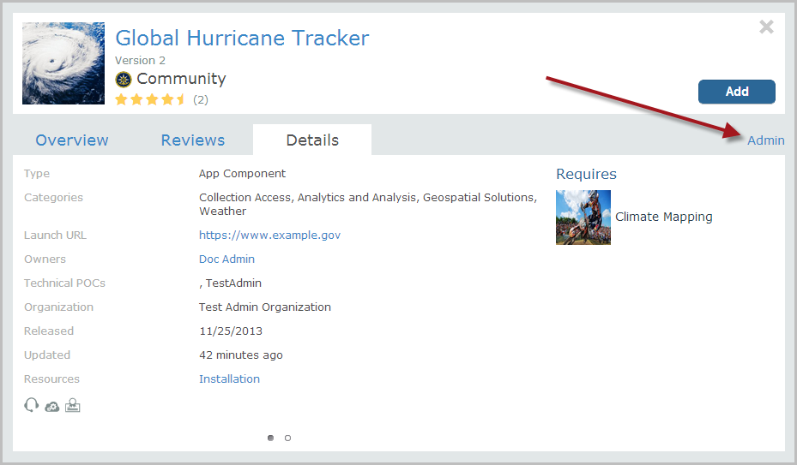

Figure : Admin Button on Listing Quick View Page

Listing owners can edit their approved listings. Users who have the ability to edit a listing will see an Admin button at the bottom of a listing Quick View window (Figure 31). Use the following instructions to edit an approved listing:

1. From the Store Discovery or Search Results Page, click on a listing icon to open the Quick View window.
2. Click the Admin button at the bottom of the Quick View to open the detailed listing page.
3. Click Edit from the Actions drop-down menu to open the approved listing form.
4. Edit the data in the form and then click Save. The changes are automatically applied to the listing.

Note: Editing a listing type may add or change the listing’s custom fields.

From the actions drop-down button, a listing owner can:

* **Edit**—Change any of the listing data. An owner’s editing permissions are determined by Store administration.
  + Without owner-edit configuration in place:
    - The listing change will be saved but not submitted, thus it has a status of “in progress.”
    - If an administrator rejects a submitted listing, the listing will have a status of “in progress.”
  + If the Owner-edit configuration is in place:
    - The owner of the listing will always be able to edit the listing, regardless of its state.
* **Copy**—Allows an owner to duplicate a listing. Owners can copy “approved” and “in progress” listings.
* **Disable**—Allows the owner of a listing to remove it from circulation. An owner will still see the listing when browsing or performing searches. Other users will not see the listing at all.

Note: Disabling a listing causes it to no longer appear in the Store, be mindful of whether the listing is required by other listings. While there will be no impact on people who have already added the listing to their instance of OWF, future users may not be able to use primary OZONE Apps or App Components if their required counterparts are disabled.

### Edit Pending Listings (Store)

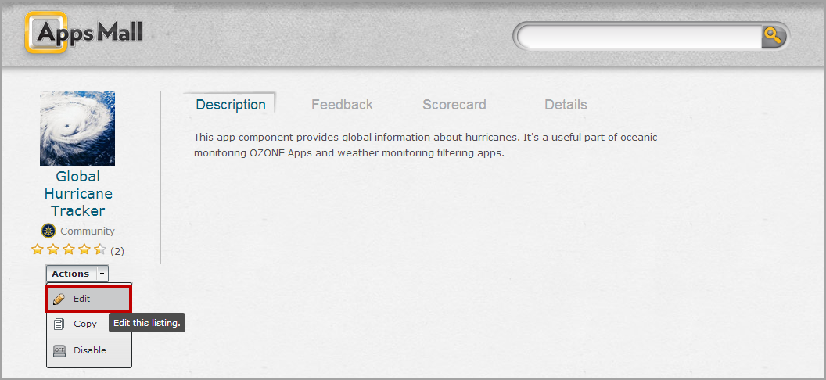

Figure : Edit Pending Listing

Users can access their pending listings through the User Menu by clicking My Listings (see section 4.2.4: My Listings Page):

1. Select a pending listing under the “Non-Approved Listings” heading.
2. To edit the Pending listing, select Edit from the drop-down actions menu (Figure 32). This opens the Listing Pending Approval form. The Listing Pending Approval form will show the same fields as the New Listing Form including the listing’s current data.
3. Make changes to this form and then click Save.
4. Click the Cancel button to revert the listing’s changes back to its pre-edited data.

Users will see the following message at the top of the Listing Pending Approval form when editing a listing which is pending approval.

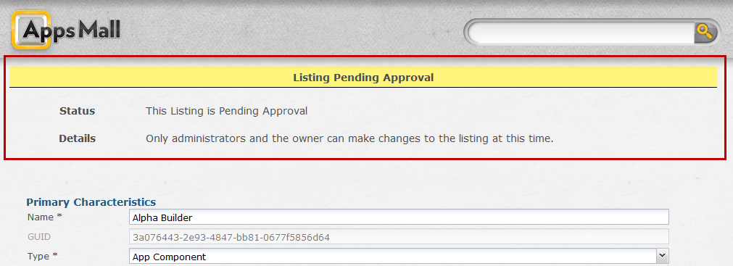

Figure : Listing Pending Approval Message

A user can also edit a listing rejected by a Store administrator.

To edit a Rejected Listing:

1. Open the listing’s detail page (Figure 32).
2. Click Edit from the drop-down Actions menu described earlier in this section. In this case, this user will see the rejection justification message at the top of the Rejected Listing form. An example is shown below:

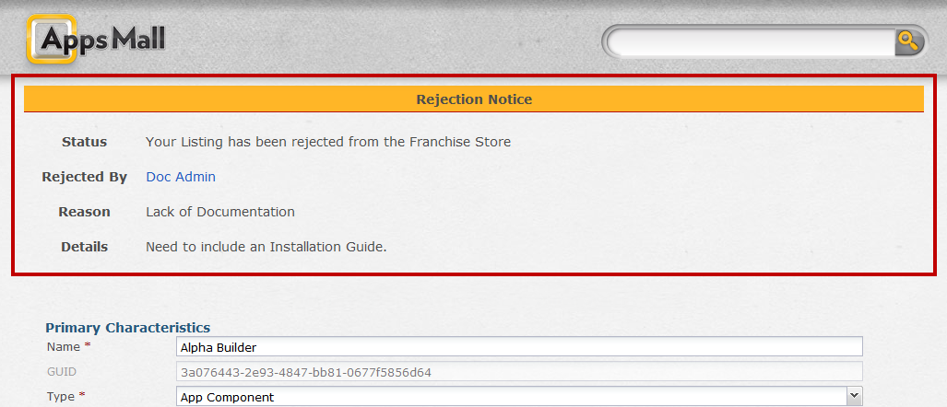

Figure : Rejection Message

1. Make changes to this form and then click Save.
2. To re-submit this listing for Store approval, click the Submit button from the listing’s detail page.

## Required Listings (Store)

### Assign Required Listings (Store)

Administrators and listing owners have the ability to designate specific listings as required by the current-viewed listing. For example, the Storm Tracking App might run correctly, but be completely useless and contain no points of interest without the Compass Listing.

To add the Compass Listing as a required listing for Storm Tracking App:

1. Click on Storm Tracking App to go to its detailed listings page.
2. Click the Specifications tab. At the bottom of the form, click the  button (see image below).



Figure : Add Required Listings under Specifications Tab

This opens the Add Required Listings window, shown below, where the listing owner or administrator can define required listing associations:

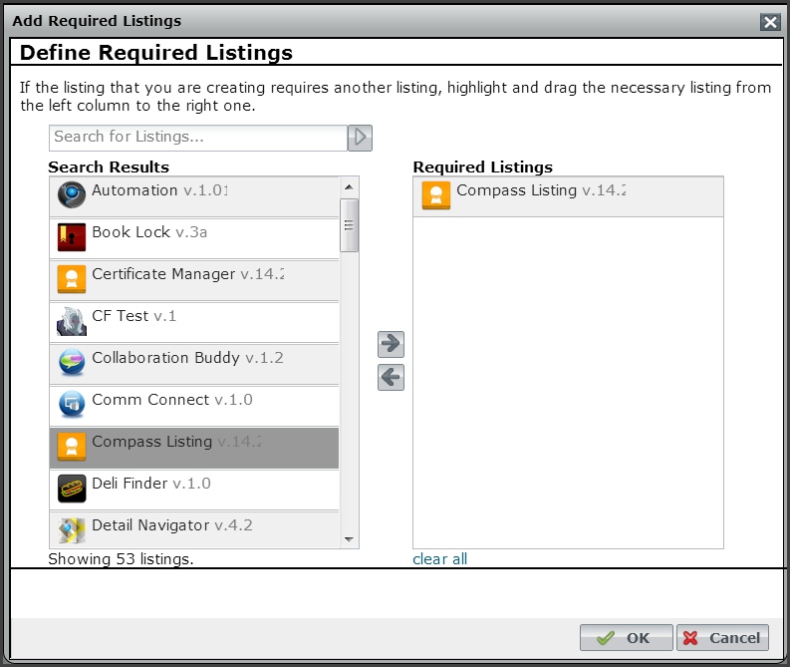

Figure : Add Required Listings Dialog

1. To add a required listing, select a listing in the Search Results pane. Click the right arrow to add the selected listing to the Required Listings pane. The user can also drag and drop the listing from the Search Results pane to the Required Listings pane.
2. Repeat step 3 to add all the required listings.

*Optional*: To remove a listing from the Required Listings pane, select the listing and click the left arrow.

*Optional:* Click the “clear all” link at the bottom of the Required Listings pane to clear all required listings.

1. When complete, click the OK button. This takes the user back to the Storm Tracking App detailed listing page. The newly added required listings will be seen under the Specifications tab at the bottom of the page (for example, see the Radar listing example, Figure 37)

When the Add Required Listings window is launched, the Define Required Listings dialog will pre-fill with up to 200 listings in ascending order from A-Z. The search box located above the Search Results column can be used to search for a specific listing. The search box employs simple-search functionality. Any search string will be returned, even if it appears in the middle of other words. For example, both “DocTest” and “October” would be returned if a user searched for “ocT.”

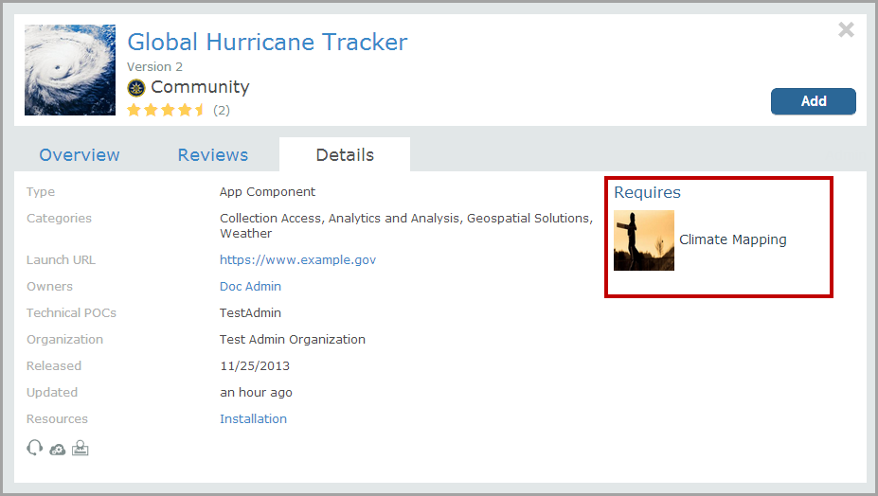

Figure : Quick Listing display of Required Listing

At the bottom of the detailed listing page, a new “Listing” Requires section has been added displaying all the required listings. The listing owner or administrator can remove the required listing relationship by clicking the  icon (which appears on hover, to the right of the required listing’s star-ratings).

Note: While the required relationships between the listings is removed, no changes are made to the actual listing. They will not be deleted from the system.

#### “Required by” Association (Store)

As discussed in 4.7: Required Listings (Store), listings can require additional listings for their functionality. When this type of association is made, not only does the primary listing require the secondary listing, but the secondary listing is labeled as being “required by” the primary listing. See the highlighted area of the figure below, for details:

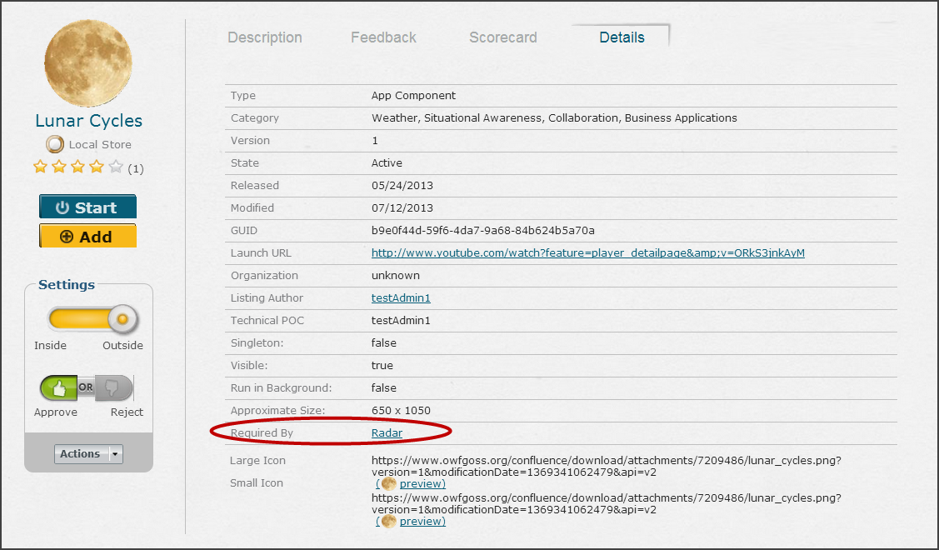

Figure : "Required By" Notation

#### Required Listings in the Change Log and My Listings

With the addition of both “required” and “required by” listings, four unique notification types have been added to “My Listings” pane:

* The listing no longer requires < listing name>.
* The listing is no longer required by < listing name >.
* The listing now requires < listing name >.

The listing is now required by < listing name >.

# Applications: Start, Edit, Delete, Share (OWF)

## Application Overview (OWF)

An application is a screen where you organize your tools. To include multiple layouts on one application, use the Application Builder (section 6: Create an App (.

Each time a saved application loads, the screen and app component layout will maintain the same look as the last time you accessed the application. Applications and their respective configurations are limitless; you can and probably will have a variety of different applications, all of which render and function independently.

You’ll receive applications in one of the following ways:

* Create your own
* Add one from the Store
* Assigned by an administrator
* Assigned to a group that has access to the app

Group assigned applications provide identical applications for each member of a group. Each group member can customize their instance of a pre-configured application. If you change your copy of an application that someone else owns, you can restore it to its default states.

### Application Pages Overview (OWF)

Application pages are individual layouts associated with an application. Application pages can be created, added, restored and deleted by the user. Users can customize application pages to include user preferred layouts and app components.

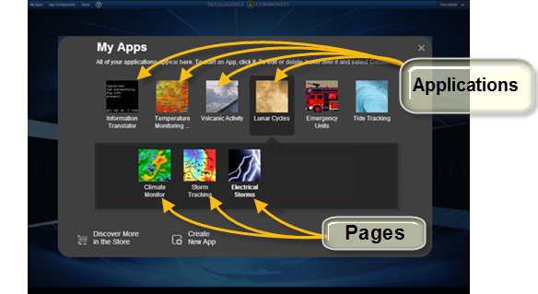

Figure : Differentiating Applications from Pages

OZONE Apps can have multiple pages. Use the feature to compile resources and make similar things easy to access. Applications and their associated pages appear in the My Apps menu.

Consider using pages to divide an application into specific sub-tasks. For example, the Disaster Recovery application has pages filled with useful tools related to disaster recovery. A user who needs this application to do their job might need the data from the following pages:

* Fire and Rescue Units
* Water and Food Supplies and Distribution Centers
* Traffic and Road Monitoring Services

To save time searching for individual applications, a user can create one application that contains those pages of related or useful tools. This provides an access point for all of your tools relating to a task.

You’ll receive applications with pages one of the following ways:

* Create your own
* Add it from the Store
* Receive it through administrator assignment

You can **Restore**, **Edit** and **Delete** your personal copies of a page. For more information on managing applications and pages see 5.3.2.4: Edit an App or Page.

* An administrator can assign an application to you. If you customize the layout and add or remove associated app components, those changes will only affect your application page (Everyone else in the system won’t see the changes. If you want to share your changes, see 5.2.2: Reorder Apps and Pages (OWF).
* If you add a copy of an application from the Store and then its owner updates it and pushed the updated app to the Store, you’ll automatically receive the change(s).   
  Note: Sync between OWF and the Store must be enabled.
* Restoring an application page returns it to its *current* default state. If the application owner updated the application after it was added to your instance of OWF, the restored version may look different than the one that you originally received.

## My Apps Menu (OWF)

The My Apps Menu lists all of the user’s applications. Applications included here are OZONE Apps, either created in OWF or obtained from the Store, and Web Apps. From the My Apps Menu, users can start an application, create new ones or search for applications in the Store. Applications can be shared, restored, edited or deleted through the manager buttons in the My Apps Menu.

To open the My Apps menu, click **My Apps** in the OZONE Toolbar.

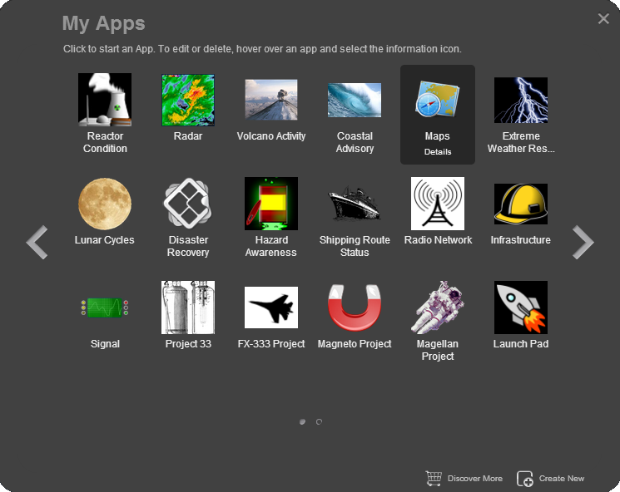

Figure : My Apps Menu

The My Apps Menu contains the following features:

  - **Pagination Arrows**: Is used to navigate through more than one page of applications.

 - **Pagination Dots**: Displays the number of pages of application available. The highlighted dot indicates the page currently displayed in the carousel. Navigate to a page of application by clicking on the corresponding dot.

 - **Discovery More**: Takes the user to the Store. Users can search for new OZONE Apps and Add them to their OWF. More information about adding application from the Store to OWF is in section 4.3: Add Listings to OWF (Store).

 - **Create New**: Enables the user to create a new application. More information about creating an application is found in section 6:Create an App (.

- **Information**: On hover, this link appears below an application’s title and icon. Clicking the link opens a details window and displays the manager buttons.

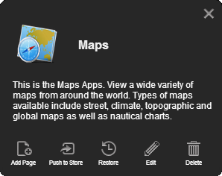

Figure : Application Details Window

Each app page has its own details window (Figure 41). This window includes a description of the application and five manager buttons: Add Page, Push to Store, Restore, Edit and Delete. More information on managing an application is found in section 5: Applications: Start.

### Start Apps and Pages (OWF)

To open an application:

1. Click the **My Apps** button in the toolbar to open the My Apps Menu.
2. Click an application, if it has only one page, it will automatically start.
3. *This step only applies to Applications with more than one page.* If the application has more than one page, then clicking the application’s icon will open a carousel displaying all the application’s pages. Click a page to automatically start a page.

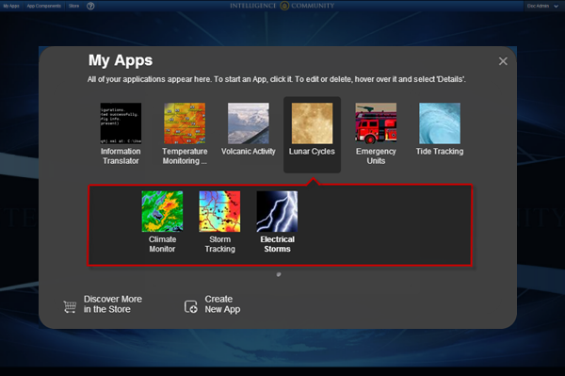

Figure : An Application with three pages

To add a page to an application:

1. Click the  button on the toolbar to open the My Apps Menu.
2. Hover over the application and click the Details link.
3. Click the Add a Page button. A dialog window will open.
4. Give the page a title (required), icon URL (optional) and a description (optional) and choose a layout.   
   Note: If you choose a custom layout, see section 6: Create an App (.
5. When finished, click OK. OWF will open the page automatically. To add app components to the page, you have to start them on the page, see section 0:
6. Start Apps and Pages (OWF).

When the My Apps Menu is re-opened, the page will appear in a carousel below the parent application’s icon. To access this carousel, click once on the parent application.

### Reorder Apps and Pages (OWF)

To reorder applications in the My Apps Menu, select an application icon and drag it to the new location within the carousel. A green line appears in the My Apps Menu to indicate where the application is placed on drop. This feature also applies to pages in an application’s page carousel, select the page icon and drag it to a new location. If the My Apps Menu or a page carousel contains more than one page of items, click and drag the intended item over the left and right arrows on either side of the carousel to place the item on the next page.

## App Information Window (OWF)

You’ll probably use the My Apps Menu most frequently to start applications, as described in 5.2.1: Start Apps and Pages (OWF). However, you can access a number of other useful features from there including the App Information Window, accessed by clicking the  that appears beside each app on hover.

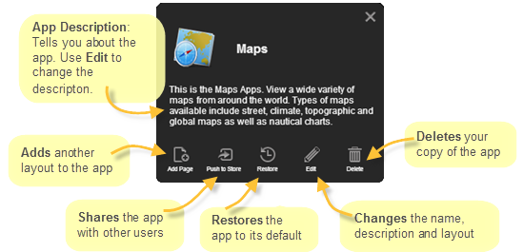

Figure : App Information Window

**App Information Window**: The window that displays the app’s description and the following features that are described in detail in the following sections:

* **Add** a page see 5.3.1: Add a Page to an Application (OWF)
* **Share** using the Push feature see 5.3.2: Push/Share Apps (OWF)
* **Restore** to *current* default state see 5.3.2.3: Restore an App or Page (OWF)
* **Edit** see5.3.2.4: Edit an App or Page (OWF)
* **Delete** see 5.3.2.5: Delete an App or Page (OWF)

### Add a Page to an Application (OWF)

All applications created in OWF start as one-page applications. The Add a Page feature allows users to add another layout which can contain the same app components in a different layout or different app components. This gives you a means to associate tools without trying to cram them all on one screen. The following sections explain how to add pages to an existing application:

To add a page to an application:

1. Click the  button on the toolbar to open the My Apps Menu.
2. Hover over the application and click the Details link.
3. Click the Add a Page button. A dialog window will open identical to the Create New App dialog described in section 6: Create an App ( .
4. Give the page a title (required), icon URL (optional) and a description (optional) and choose a layout.
5. When finished, click OK. OWF will open the page automatically.

When the My Apps Menu is re-opened, the page will appear in a carousel below the parent application’s icon. To access this carousel, click once on the parent application.

### Push/Share Apps (OWF)

Applications are frameworks that allow information from different places to communicate in a customizable environment. Good applications will bring together the tools you need to accomplish a task. They’ll be arranged in a way that makes them easy to use and understand. If you make something that does this, you can share it with other users in one of two ways depending on the way your system is configured:

#### Push Apps to the Store (OWF)

The Push to Store feature sends application data from OWF to a connected Store. The data is sent as a JSON file and contains the following application information:

* Application and Page title, icon and description
* Page layout data
* App component(s) definition(s)

In order to push to the Store, OWF must be connected to a Store and the user must be the owner of the application. If the user is not the owner, the “Push to Store” button will not appear as one of the Application Manager Tools because users can only push applications to the Store that they own.

Note: Administrators can change ownership using the App Editor. For more information, see the OWF Administrators Guide.

Note: To use this feature, sync with the Store must be enabled. This should be enabled by default. If it is not, see instructions in the OWF Configuration Guide.

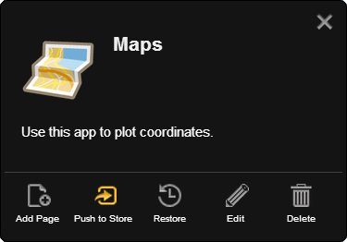

Figure : The Push to Store Button on an Application

To push an application to the Store:

1. Click the  button on the toolbar to open the My Apps Menu.
2. Hover over an application and click the Details link.
3. Click the Push to Store button. This action sends the application data to the Store.   
   Note: If OWF is connected to more than one store, the user must click on the Store where they intend to send the app.
4. If the app is successfully added to the Store, the screen will switch to the app’s listing page in the Store and one of the following messages will appear:

* You added a new App to the Store.
* The App is already in the Store (i.e. no change).
* The App is already in the Store and has been updated.

Note: If an error occurs, ask an administrator to checks the app components’ URLs first. The Store requires that app components use fully qualified URLs (i.e. **https://myserver.com:8443/ozone/path-to-appcomponent/appcomponent**).

1. Click the Submit button to send the App listing and any of its required app component listings to a Store administrator for approval.

* After a Store administrator approves the application, it will be available in search results for Store users.
* For more information about editing the App in the store, see section :

##### Push Updates to the Store (OWF)

If you’re the owner of an App and you update it after adding it to the Store, you should push the update to the Store to provide users with the latest of the app. To replace the outdated store version, follow the steps in 5.3.2.1: Push Apps to the Store (OWF) to send the update to the Store. As a best practice, App Components should have a universal name defined. If they do not, then every time they are pushed to the store, the App Components with no universal name are added to the store as new App Components. Thus, the same app component may clutter the store with multiple copies.

#### Share Apps in OWF (OWF)

If your instance of OWF is not connected to a Store, you won’t see the Push to Store button. Instead, you’ll have a Share button on the App’s information screen:

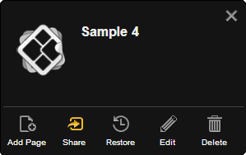

Figure : The Share Button on an Application

When you share an App in OWF, you’re allowing administrators to add it to other users’ instances of OWF. You must be the app’s owner to share it.

#### Restore an App or Page (OWF)

A user can receive an application through administrator assignment or through the Store. Once added, the user can modify their personal copy of the application in OWF. The Restore feature reverses these changes and returns the application to the *current default state*. If the application’s owner made changes after the user received the application, then the restored version of the application will differ from the one that originally appeared in the user’s My Apps Menu.

If a user restores an application with multiple pages, then all of the pages in the application are restored. Pages in an application can be individually restored.

To restore an application or a page to its *current default state*:

1. Click the  button on the toolbar to open the My Apps Menu.
2. Hover over an application (or page) and click the Details link.
3. Click the Restore button.
4. The application and all associated pages will return to its *current default state*.

#### Edit an App or Page (OWF)

The edit application feature allows users to change an application’s title, icon and description. Layouts are only editable for pages in an application; single page application layouts are not editable. If a single page application added a page, then the layout for either page (the original and the added page) are editable.

To edit an application:

1. Click the  button on the toolbar to open the My Apps Menu.
2. Hover over an application (or page) and click the Details link.
3. Click the Edit button.
4. A Dialog window will open:
   1. Update the Title, icon URL or description
   2. Click OK. If editing a page, this will load the Application Builder. See section 6: Create an App ( for instructions.
5. Make changes to the page’s layout, then click the Save button.

Changes made to an application or page only affect the user’s personal copy of the application or page. If the user is the application’s owner and makes changes to the application or its pages, then the next time they push the application to the Store the changes are sent to the Store. Users who have this application will see these changes applied to their personal copies of the application and pages.

Note: An error message will appear if the user attempts to save the application with an unauthorized layout assignment. An example of an unauthorized layout assignment is if the user has a Tabbed layout pane with multiple app components and then attempts to assign a Fit layout to that pane. The multiple app components cannot fit into one Fit pane and the user will receive an error when attempting to Save the layout.

##### Rename an Application (OWF)

To rename an application:

1. Click the  button on the toolbar to open the My Apps menu.
2. Hover over the application to modify, click the Details button below the application title.
3. Click the Edit button.
4. This opens the Application details window. Modifying the Title field, click OK.
5. The Application Builder window will open. Click Save.

#### Delete an App or Page (OWF)

To delete an application or a page:

1. Click the  button on the toolbar to open the My Apps Menu.
2. Hover over an application (or page) and click the Details link.
3. Click the Delete button.
4. A warning message will appear.
5. Click OK to confirm the deletion.

If the application is used by only the owner, the application will be deleted from the system along with all associated pages. If the application has more than one user (i.e. other OWF users received this application through the Store) the user deleting the application is deleted from the list of the application’s users and the application remains in the OWF system.

If the application owner deletes a page, other users of this application will not be affected by this change until the owner pushes the application to the Store. When an application with deleted pages is pushed to the Store, all the application’s users will see the pages disappear from their copies of the application.

# Create an App (OWF)

OWF includes an App Builder where you can design and customize applications. This can be useful to create your own workflows.

To create a new application:

1. Click  in the toolbar to open the My Apps.
2. Click “Create New” at the bottom of the screen to open the Create New App window.
3. Give the application:
   1. A title (required)
   2. An image URL (optional) that appears in the My Apps window.
   3. A description (optional)

Note: The application cannot be saved without a title.

1. Choose a layout for the application. Click the radio button beside the selected layout method. Layout options include:
   1. **Choose a template** – Choose one of twelve premade layouts.
   2. **Copy the layout of an existing App** –Clicking this causes a drop-down menu to appear below the selection title. Choose an application from this menu. The new application will adopt the layout of the selected application. However, it will not copy the app components associated with that layout.
   3. **Create a new layout** – Opens the Application Builder allowing the user to create a new layout. More information on creating a new layout is found in section 6.2: Use the App Builder.
2. Click OK. The application will automatically open unless you selected “Create a new layout,” if that is the case proceed to section 6.2: Use the App Builder.
3. To add application components to the App, click the App Component button on the OZONE Toolbar and select components by clicking them. If the App has more than one pane, click the pane where the component will open.

Next time the My Apps menu is opened, it will contain this app. This app belongs to the user who created it and it cannot be shared with other OWF users until it is shared with the Store. To do this, open My Apps and click the Details button on the App, then, select Push to Store.

Note: Creating a new application, in effect, creates a one-page application. The application and the single page share the same title, description and icon. The layout assigned to this application applies to the single page rather than the application. Users can add additional pages, and therefore additional layouts, to this application. When more than one page is added to an application, the user has the ability to change the single page’s properties. Also each page is edited independent from other pages or the parent App.

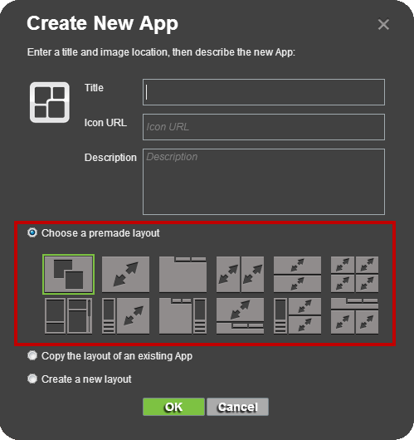

Figure : Premade Layout Templates

Descriptions and instructions for adding app components to the five layouts are explained in the following sections. Information on customizing application layouts can be found in section 6.2: Use the App Builder.

## App Builder Components (OWF)

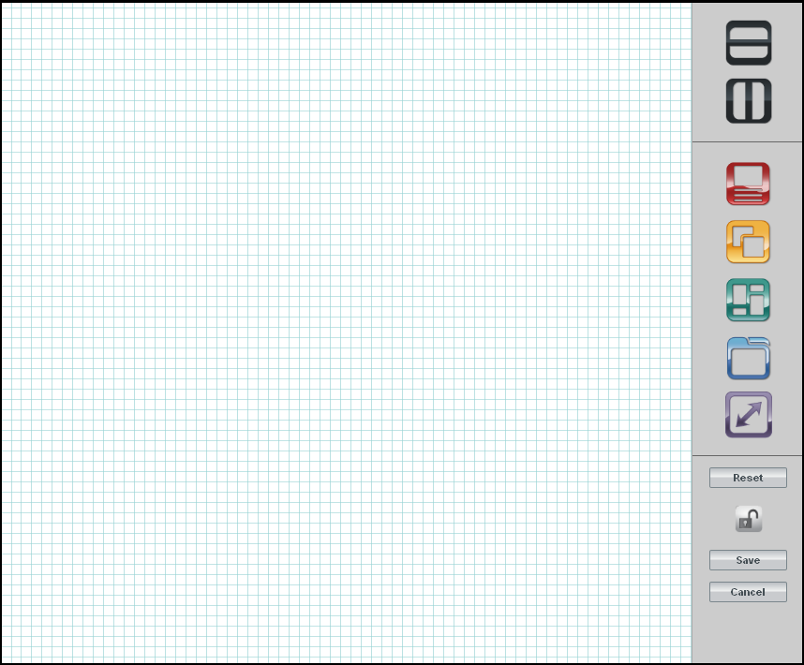

Figure : Application Builder

The Application Builder allows users to create custom layouts for their applications.

When you opens an App, it has the potential to display a variety of information. What the user sees depends on the application layout. There are five layout types. Each type can be used as the only layout for the App or used as a portion of the application configuration. The five types are included in a list of application layout templates users can select from when creating their own Apps. The types along with other App Builder tools are described in the following sections.

### App Layout Dividers (OWF)

When using the Application Builder, there are two ways to divide the application into sections:

*  - Horizontal Dividers are used to divide the application (or sub-sections of application) into upper and lower panes.
*  - Vertical Dividers are used to divide the application (Or sub-sections of the application) into left and right-side panes

### App Layout Types (OWF)

OWF supports five different layout types and any conglomeration of those types. Each type is described in this section. During the design process, any of the layouts can comprise a whole application or a pane within application:

*  - Accordion Layout. See section 6.1.3: Accordion Layout for more details.
*  - Desktop Layout. See section 6.1.4: Desktop Layout for more details.
*  - Portal Layout. See section 6.1.5: Portal Layout for more details.
*  - Tabbed Layout. See section 6.1.6: Tabbed Layout for more details.
*  - Fit Layout. See section 6.1.7: Fit for more details.

### Accordion Layout (OWF)

Accordion layouts display app components in equal, horizontal panes. When an app component is added to the application, all the app components are resized to display equally in the OWF window. The OWF window does not scroll. Each individual app component (as shown below) will scroll using its own scroll bar.

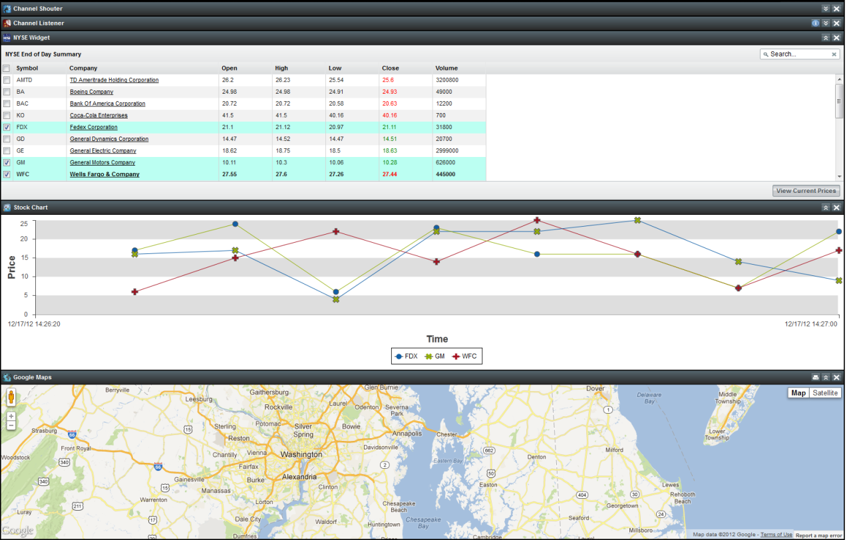

Figure : Accordion Layout

### Desktop Layout (OWF)

**Desktop layouts,** similar to the desktop on most personal computers, allow the user to open app components from the My Apps menu and place app components freely in the window and minimize them on a taskbar.

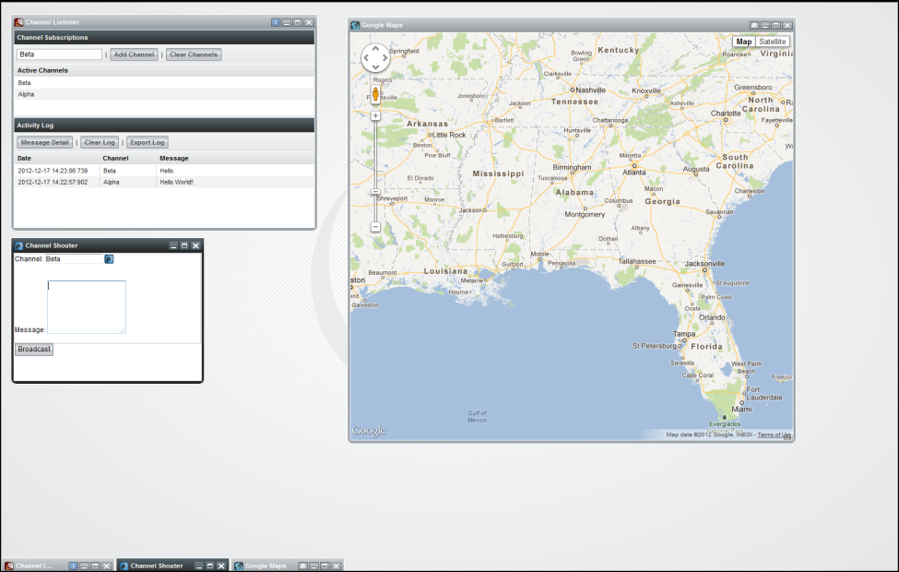

Figure : Desktop Layout

### Portal Layout (OWF)

**Portal layouts** comprise a column-oriented layout that organizes app components of varying heights. Each new app component loads above the first one on the screen. The user drags a dividing bar to specify app component’s height. The app components and the OWF window scroll.

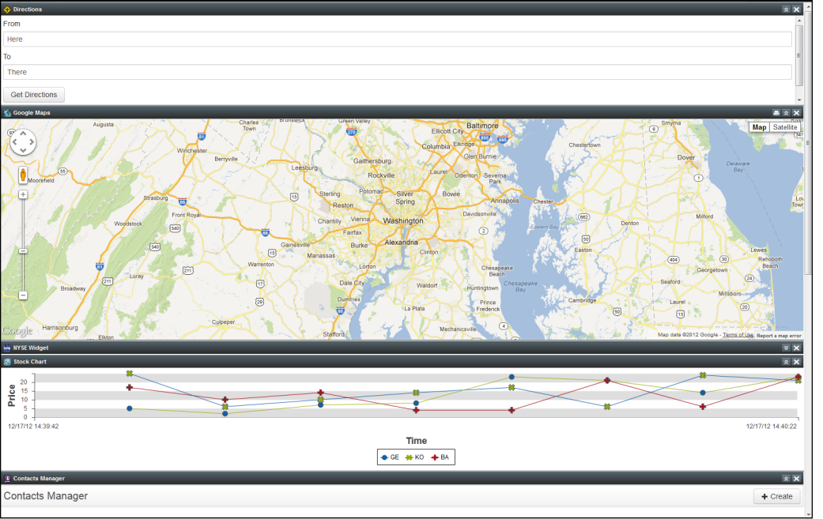

Figure : Portal Layout

### Tabbed Layout (OWF)

Tabbed layouts display one app component per screen. Like browser tabs, the tabs at the top of the screen switch from one app component to another.

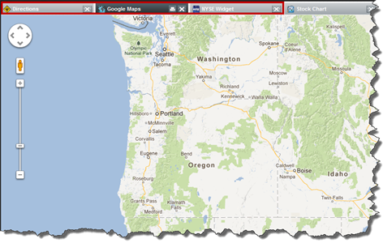

Figure : Tabbed Layout

### Fit Layout (OWF)

**Fit layouts** allow a user to place a single app component on the screen. An open app component shows no border or chrome and will occupy the full size of the available framework. Think of it like making a PowerPoint presentation full-screen within the designated OWF window. If a user wishes to open an additional app component, they will be notified that the initial app component will be replaced by the new one.

Note: Some app component s are opened automatically by other app components. In these cases, the app component s will “float” on top of the application.



Figure : Fit Layout

## Use the App Builder (OWF)

The following walkthrough will explain how to build a new application with Accordion, Desktop and Tabbed layout sections:

1. Click  on the toolbar to open the My Apps menu.
2. Click “Create New App” button to open the Create New App window.
3. Enter a title (required), image location (optional) and description (optional) for the new application.
4. Select a layout from the three layout choices. For this walkthrough, click the radio button next to the “Create a new layout” link.
5. Click OK. This will open the Application Builder.
6. Divide the screen horizontally by dragging the  button to the Application Builder grid or clicking the  button.
7. Divide the upper grid section vertically by:
   1. Dragging the  button to the upper level of the designer.
   2. Clicking the upper portion of the Application Builder to highlight the top section. Click the  to divide the highlighted section vertically.

Following steps 1 through 7 correctly, the screen should mirror the image below:

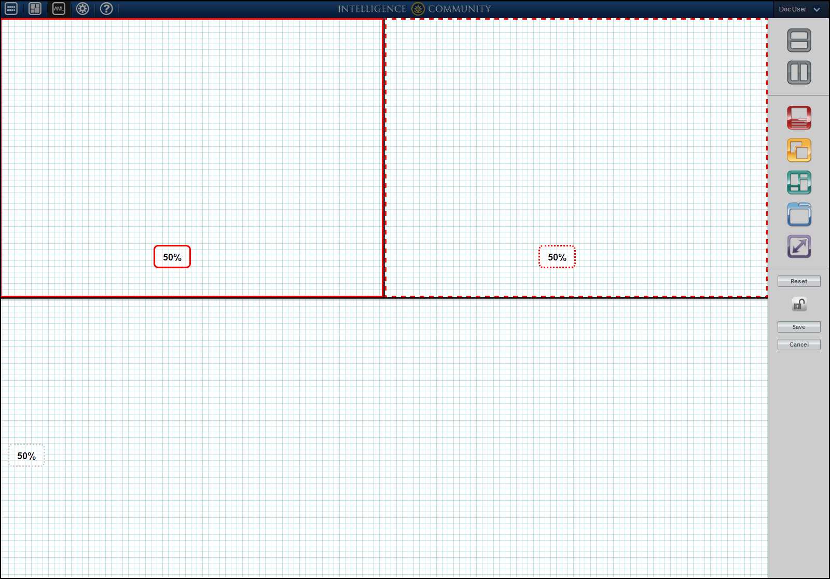

Figure : Creating an Application Layout

The application’s layout is now divided into multiple sections. Each section can be divided further or assigned a layout.

To divide a section:

* Drag the Vertical or Horizontal Divider into the section.
* Select a section and then click the Vertical or Horizontal Divider.

Note: Clicking the Vertical or Horizontal Divider to split a pane leaves the top/left pane in focus as indicated by a solid red border. If a user then clicks on a layout type, the layout would be assigned to this pane because it is in focus. To change focus to another pane, click on the pane or use the Tab keyboard navigation to first select a pane and then press Enter to focus on it.

To assign a layout to a section:

* Drag a layout type icon from the sidebar into the section.
* Click the section and then click a layout type.

When a section of the application is clicked, it is in focus indicated by solid red border. Its partner section of the application is highlighted with a broken red border; the combined sections (solid red border and broken red border) equal 100 percent of a viewing area. For example in Figure 53, the top right portion is surrounded by a solid red line. The top left portion is surrounded by a broken red border. Together, they equal 100 percent of the upper pane of the application.

To resize sections, drag the Divider between them or type a different value into one of the section’s screen percentage box. The related pane will automatically adjust. At any point during the application creation, it can be saved, reset or cancelled.

Note: A user can also use pixels values instead of a percentage value when they need to make a more precise cell size. In the image above, a user would be able to make either of the application sections an exact number, 250px, for example. When this happens, its partner presents the label “Variable”. Entering a number and using a P or a PX will designate pixels.

Continuing the walkthrough, the user can drag in or click on the layout type icons to assign layout types to a section.

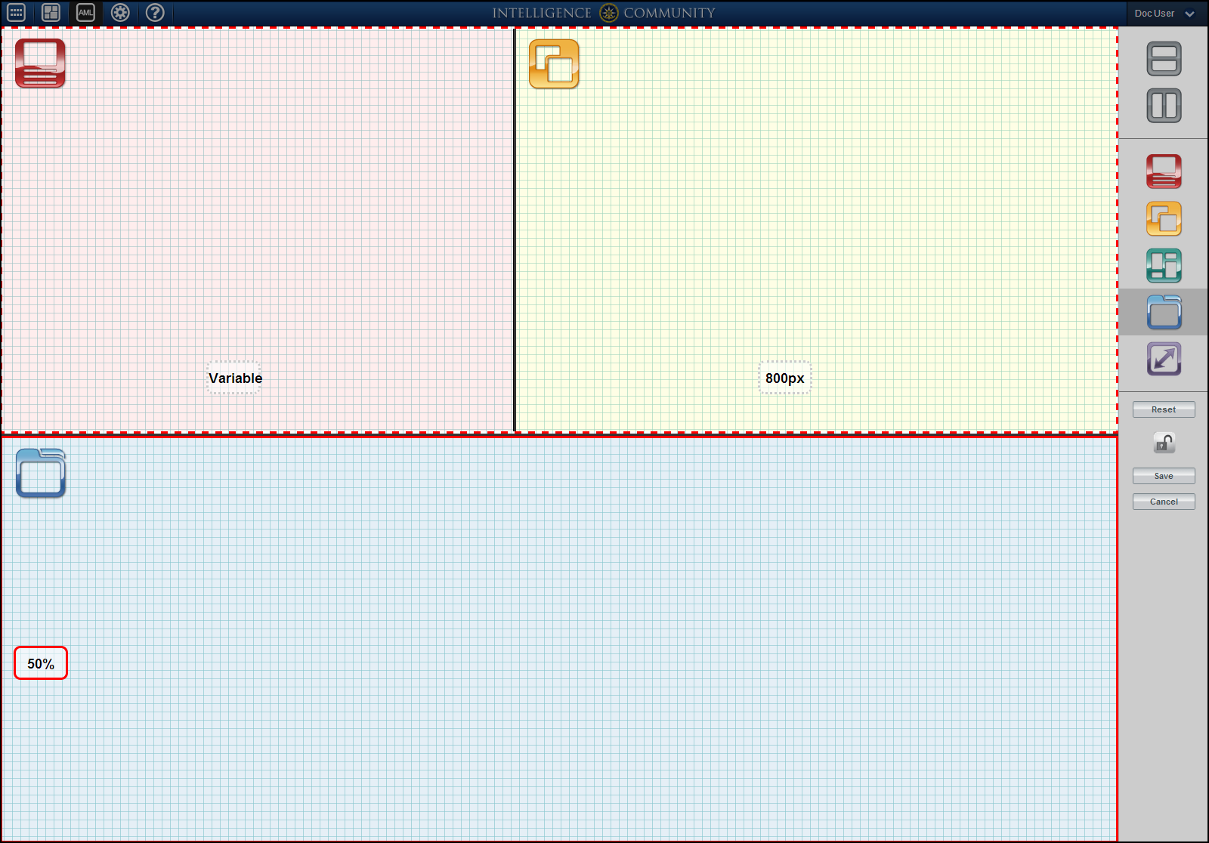

Figure : Application Builder with Layout Icons

In the image above, each section of the application has a layout type icon in place.

The upper-left section contains the Accordion layout icon and has changed to a red background. The upper-right section contains the Desktop layout icon and has changed to a yellow background. The lower section is a Tabbed layout and has changed to a blue background. Each individual section allows for the layout of app components in accordance with the properties of the layout icon. Once the layout icons are in place, the user can save the application. After saving the application, it will open automatically. It can also be opened from the My Apps Menu by clicking the  button. You can now populate the application panes with app components from the App Components carousel. For more information about adding app components to an application, see section 7.3: Start App Components (OWF).

Additional Application Builder tools are:

*  - Clears layout modifications to the application.
*  - Lock/Unlock application – Use this button to restrict changes to the application layout and the app components displayed on it. When the application is locked, app components cannot be added or removed and sections cannot be edited, however, the layout of a locked application is still editable.
*  - Saves the application, closes the Application Builder and then opens the application.
*  - Cancels changes made since the last Save or since entering the Application Builder.

After the application opens, you’ll want to add app components. See section 7.3: Start App Components (OWF).

# App Components (OWF)

## Definitions

### App Components

An application (app) component is a lightweight, single-purpose application that offers a summary or limited view of a larger application. In OWF, an application component is a global description for a piece of Web content that can be configured by the user and displayed within an application.

#### Singleton App Components

Singleton app components allow only one instance of the app component to open in an application. (Users can open multiple instances of regular app components on each application.) If a Singleton app component is open on an application and a user tries to open another instance of the app component, the open instance will move to the forefront of the screen. Administrators may make an app component a Singleton for numerous reasons. For example, preventing users from opening multiple instances per application may reduce confusion, increase performance (if the app component uses a substantial amount of memory), or address another need.

#### Background App Components

Background app components run but do not appear on a user’s application. They often serve as caching and logging tools that do not have a user interface. Background app components can be obtained from a Store server or configured by an OWF administrator. Most users will not be aware that Background app components are running in their instance of OWF. However, Background app components will appear on the Application Component Switcher. Closing them may interrupt data transfer from other app components. Use the Application Component Switcher to close Background app components. After selecting a Background app component, a warning message will appear. To close the app component, select OK. If the Background app component is visible (an administrator has not hidden it from the App Components menu), a user can restart it by dragging it from the App Component menu to an application.

Note: Background app components do not appear on OWF applications. These app components will often interact with other app components and can be used for caching and logging.

#### Required App Components (OWF)

In the Store, listings can designate that specific listings are required by other listings, see 4.7: Required Listings (Store). For example, the Store Tracking listing may require the Compass Listing. This is how the relationship works when you add those listings to your OWF as app components:

* When you **add** Store Tracking to your OWF, you will also add Compass.
* If you **delete** Store Tracking, you’ll keep Compass.
* If you **delete** Compass, Store Tracking will delete too.

You must create the “required relationships” in the Store. OWF supports the relationships but it does not have a means to create them.

## App Component Menu (OWF)

Users access their app components from the App Components Menu by clicking the  button in the toolbar. Once open, the App Components Menu appears as a carousel.

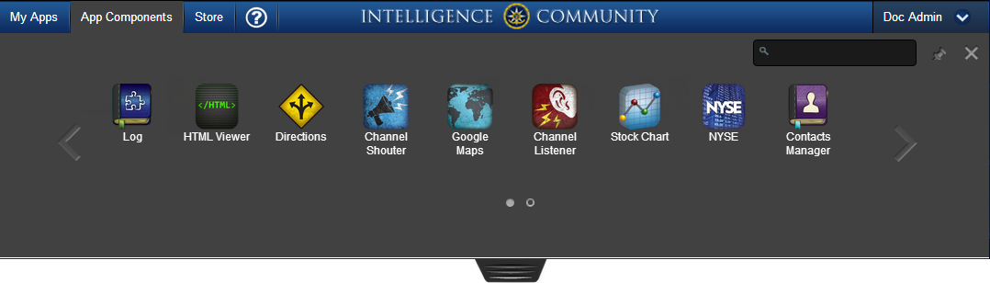

Figure : App Components Carousel

The App Components carousel contains the following features:

  - **Pagination Arrows** - Used to navigate through more than one page of app components.

 - **Pagination Dots** - Displays the number of pages of app components available. The highlighted dot indicate which page is currently displayed in the carousel.

 - **Expander Tool** – Click the expander and drag down to increase the size of the App Component display window.

 - **Search** - Type an app component title to search for it. This search is **not** case sensitive.

 - **Pinning Tool** – Click the pinning tool to make the carousel remain open on the screen. To allow the carousel to close after selecting an app component, click the pinning tool again.

 - **Close Menu** - Exits the App Component window.

The App Components Menu displays the app component’s title and icon. For more information about the app component, hover over the app component icon to reveal the Information link. Clicking the  opens the Information Window (Figure 56) which provides a description of the app component and a Remove link. Clicking the Remove link will delete the app components from the user’s OWF and it is no longer displayed in the App Components menu. More information on deleting app components is in section 7.5: Delete App Components.

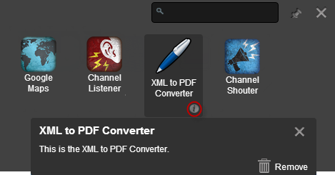

Figure : App Components Menu Information Window

### Search for App Components (OWF)

OWF provides a search feature allowing users to search for app components in the App Components Menu. Located in the upper-right portion, this field filters the list of app components by title. Users can search the app components title or description; the search feature is case insensitive. The App Components Menu will refresh and display all app components that meet the search criteria.

### Reorder App Components in the App Component Menu (OWF)

To reorder app components in the App Components Menu’s:

1. Open the App Components Menu by clicking the  button on the toolbar.
2. Click an app component, then drag it left or right in the carousel. Release the mouse to complete the move.

Note: Users can reorder the App Components Menu in carousel and expanded view.

## Start App Components (OWF)

App Components will automatically start when you add them to an application or start an application where the component was already added. Thus, you must add components to an application to start them. To do that:

1. Click the  button on the toolbar to open the My Apps Menu, select the application where the component will run.
2. Next, click the  button on the toolbar to open the App Component Menu.
3. Click to place or drag app components from the menu into the application. The app components will start in the highlighted application pane.
4. Repeat steps 2 and 3 to add more components to the application.
5. If the App Component Menu is pinned, click the X in the upper-right corner to close it when you’re finished.

#### Intents: Start App Components that use them (OWF)

When an app component sends an intent request, a pop up window appears displaying all of the open app components that can receive the requested intent action and data for an intended purpose (graphing, displaying, etc.).

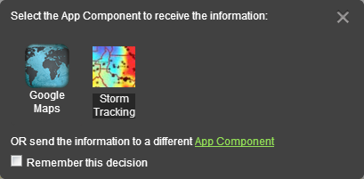

Figure : Instructional Window for Intent

Select an app component to accept the requested intent:

* Click one of the app components displayed on the window OR
* OR click the App Component link to send the information to an App Component that is not open on the screen:

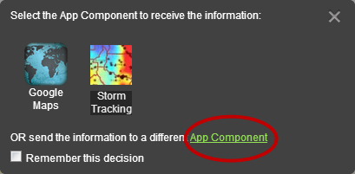

Figure : Send information to a different App Component

Note: Checking the “Remember” box will allow the selected app component to automatically open the requesting app component’s data. This function will continue until the user breaks the connection by closing either the sending app component or the receiving app component.

After a user selects a receiving app component, the intent data is automatically sent to and processed by the receiving app component. To place the app component on the App, click or drag it from the menu into the application. If every pane in the application is occupied by other app components, then selecting a pane to place this app component will replace the app component currently there. Once the receiving app component is in place and open in the application, it will receive the sending app components intent request.

## Send Apps to the Store (OWF)

The Push to Store feature sends application data from OWF to a connected Store. The data is sent as a JSON and contains the following application information:

* Application and Page title, icon and description
* Page layout data
* App component(s) definition(s)

In order to push to the Store, OWF must be connected to a Store and the user must be the owner of the application. If the user is not the owner, the “Push to Store” button will not appear as one of the Application Manager Tools because users can only push applications to the Store that they own.   
Note: Administrators can change ownership using the App Editor. For more information, see the OWF Administrators Guide.

Note: To use this feature, sync with the Store must be enabled. This should be enabled by default. If it is not, see instructions in the OWF Configuration Guide.

To push an application to the Store:

1. Click the  button on the toolbar to open the My Apps Menu.
2. Hover over an application and click the Details link.
3. Click the Push to Store button. This action sends the application data to the Store. Note: If OWF is connected to more than one store, the user must click on the Store where they intend to send the app.
4. If the app is successfully added to the Store, the screen will switch to the app’s listing page in the Store and one of the following messages will appear:
   * You added a new App to the Store.
   * The App is already in the Store (i.e. no change).
   * The App is already in the Store and has been updated.

Note: If an error occurs, ask an administrator to check its app components’ URLs first. The Store requires that app components use fully qualified URLs (i.e. [**https://myserver.com:8443/owf/path-to-appcomponent/appcomponent**](https://myserver.com:8443/owf/path-to-appcomponent/appcomponent)).

1. Click the Submit button to send the App listing and any of its required app component listings to a Store administrator for approval.
   * After a Store administrator approves the application, it will be available in search results for Store users.
   * For more information about editing the App in the store, see section 5.3.2.4: Edit an App or Page.

## Delete App Components (OWF)

Users can remove any directly assigned app components from their instance of OWF. This action will not delete the app component from OWF, it only deletes the app component for that user. Only administrators can delete app components from the system.

To delete an app component from a user’s instance of OWF:

1. Open the App Components Menu by clicking the  button in the toolbar.
2. Hover over the app component to reveal the , then click it.
3. Click Remove in the Information Window.
4. Click OK on the warning pop-up.

Note: Users cannot delete app components that have been given to them through a group assignment.

### Deleting Required App Components (OWF)

Like any other app component, required app components can be deleted from the App Components Menu. If a user deletes a Required app component, any app components that require the deleted app component will automatically be deleted after the system displays a warning notification (Figure 59). Other app components that are related to the dependent app components will remain. For example, Jane’s Tool Set requires the Search Filtering Tool, the Chat Client and the Traffic Monitoring app components. If the Search Filtering is deleted, the Jane’s Tool Set will be deleted.

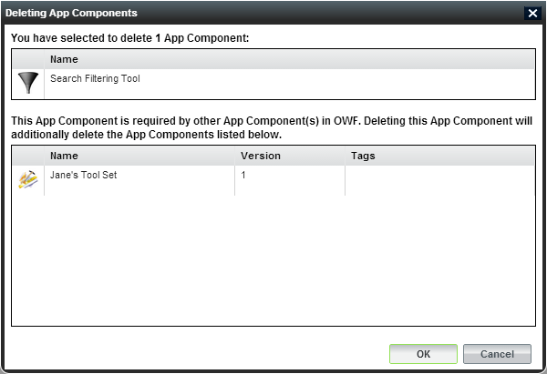

Figure : Delete App Component Warning

# Customize your experience

## Update your Profile

### User Profile (Store)

From the contributor profile page, users may view all of the listings that the contributor has added (contributions) to the Store, as well as any comments that the contributor may have left for other listings throughout the Store.

To edit your profile:

1. Click User Profile from the drop-down User Menu.
2. Click the Edit link on the right-side of the screen to change the description included in your profile.
3. Click save.

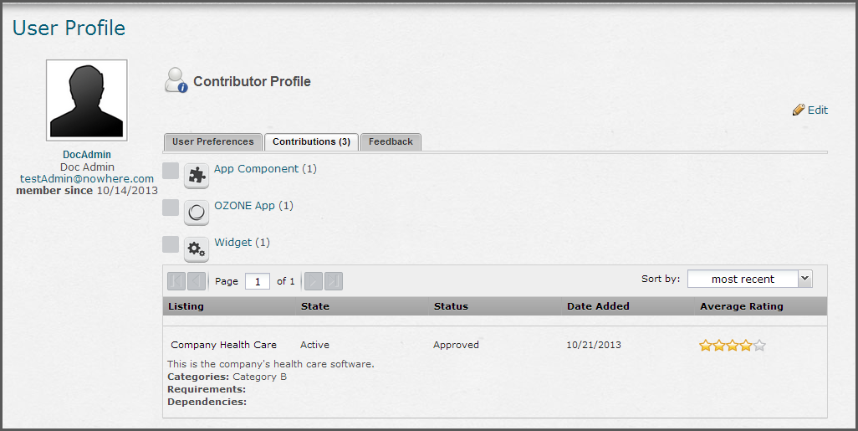

Figure : Contributor Profile Page

Only the creator of the profile or an administrator can edit a particular profile. Once saved, the profile will be available to users of the Store.

The Contributor Profile also contains the following tabs:

*  — Allows the users to enable or disable Store animations. Some Stores users prefer to not see animations for personal or system performance reasons. By default, the animations are disabled. To enable, click on the User Preferences tab and click the Enable Animations checkbox.
*  — Shows all listings contributed by the user. Under the Contributions tab, listing types (App Component, OZONE App and Web App shown in the image above) are paginated and sorted alphabetically. A user can click the plus sign to the left of a listing type to see more details about the listings categorized by that listing type. In this expanded view, listings that are the same type can be sorted by listing name, state, status, date added or average rating by clicking on the associated column header. Additionally, if an administrator has uploaded a type icon image, it will be shown next to the individual types.

Note: When a user (the listing owner) checks their own profile, they will see their approved and unapproved listings under the Contributions tab. When a user reads a Contributor Profile other than their own, only the approved listings appear.

*  — Shows the total number of comments (including ratings) that the contributor made for the Store listings. Comments can be sorted by both name and date fields.

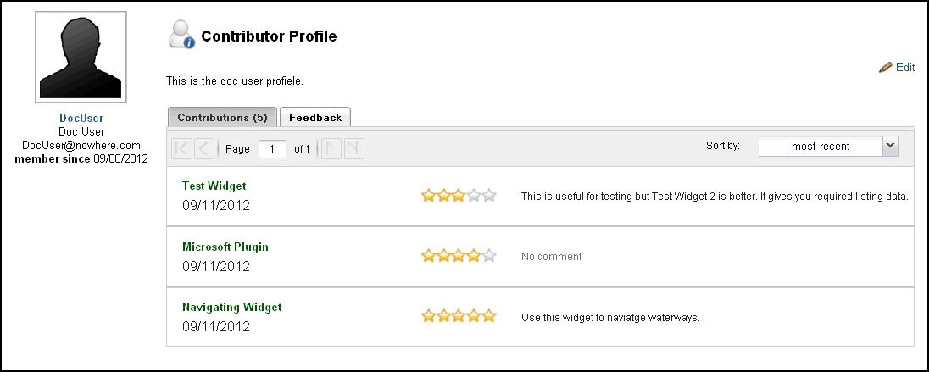

Figure : Contributor Feedback

### User Profile (OWF)

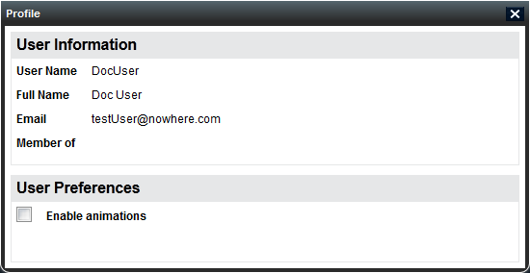

Figure : OWF Profile Information

In OWF, users cannot customize their User Information.

They can view it:

To access the profile in OWF, click the Profiletab from the drop-down user menu. The OWF Profile page shows User identification including:

* username
* full name
* e-mail
* a list of the user’s groups

Note: Enabling animations may cause issues with third-party plug-ins like Google Earth.

## Change themes

### Themes (Store)

The Store ships with three themes: Carbon, Cobalt and Gold.

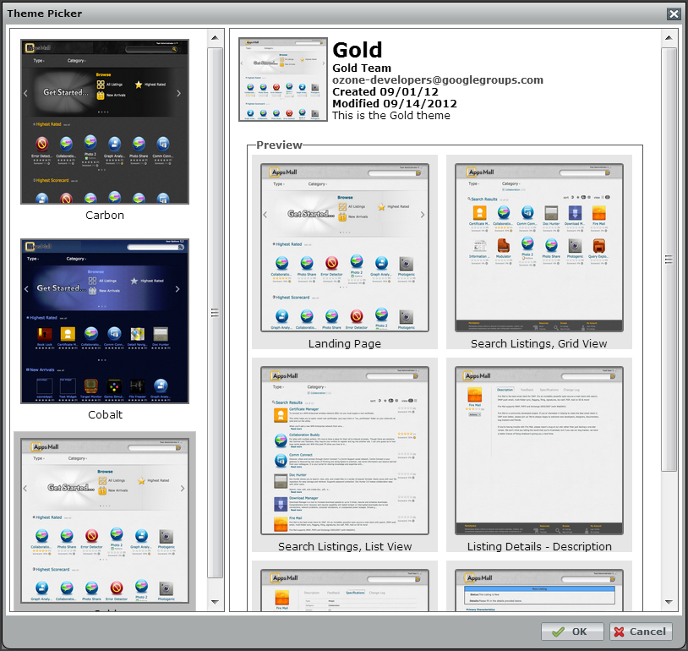

Figure : Theme Picker Window

To change Store themes:

1. Click the drop-down User Options located above the search bar on the right-side of the Banner.
2. Select (Store) Themes, the Theme Picker Window will open.
3. Click a Theme from the left column to select it.
4. Click OK, the picker will close and the screen will change to the new theme.

### Themes (OWF)

In addition to the default Cobalt theme, OWF provides two accessibility themes to accommodate users with vision challenges.

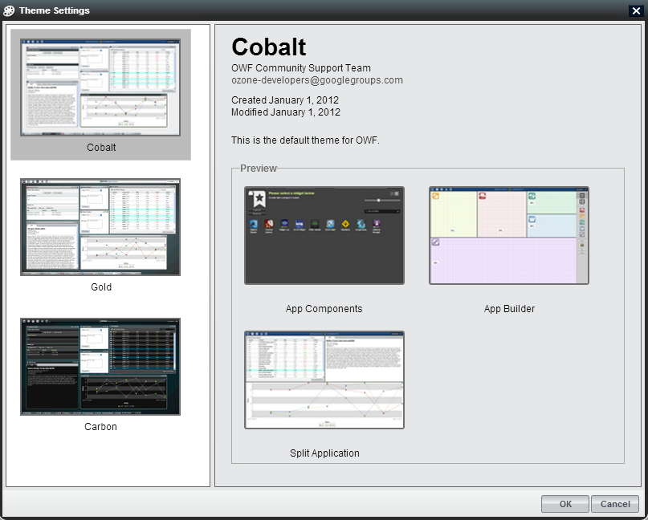

Figure : Theme Settings Window

To select a theme:

1. Open the drop-down User Menu in the toolbar, and then click the Themes button.

The Theme Settings window will open. Theme options will appear in the left column. The current theme will display in the right column.

1. Select a theme in the left column, then click OK. The theme will automatically change to the new selection.

#### Accessible Themes (OWF)

OWF ships with the following themes that were specifically designed for accessibility:

* **Gold** - A high contrast theme with white backgrounds and dark text.
* **Carbon** - A high contrast theme with dark backgrounds and light text.

## Enable/Disable Animations

### Enable/Disable Animations (Store)

To improve lag on slower systems, you may want disable animations.

To do this:

1. Click User Profile from the drop-down User Menu.
2. From the User Preferences tab, uncheck the Enable Animations box.
3. This disables animations in the Store. To disable animations in the OWF, follow the steps in 8.3.2: Enable/Disable Animations (OWF).

Note: Enabling animations may cause issues with third-party plug-ins like Google Earth.

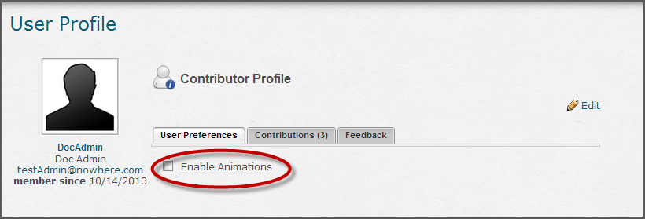

Figure : Animations in the Store

### Enable/Disable Animations (OWF)

To improve lag on slower systems, you may want disable animations.

To do this:

1. Click Profile on the drop-down user menu.
2. Uncheck the Enable Animations box.

To enable OWF animations, click the Enable Animations checkbox.

# About window

### About (OWF)

Assessed by clicking the drop-down user menu on the right-side of the screen, the About window displays information that can be customized by an administrator.

### About (Store)

Assessed by clicking the About link in the Resources section of the Footer of the Store, the About window displays information that can be customized by an administrator.

# Appendixes

###### Glossary

Table : Glossary

| Term | Definitions |
| --- | --- |
| Accordion Layout | Accordion layouts display app components in equal, horizontal panes. When an app component is added to the application, all the app components are resized to display equally in the OWF window. The OWF window does not scroll. Each individual app component (as shown below) will scroll using its own scroll bar. |
| Affiliated Store | An Affiliated Store is a store that another organization uses for their system. When a local store is connected to an affiliated store, users in the local store can search for and add listings from the affiliated store. |
| Applications/Apps | A user-defined template where application components are added, arranged and used. Applications have customizable layouts that organize application components and improve users’ workflows. |
| App Builder | A tool in OWF where users can create or edit their own customized Applications. |
| App Component | A lightweight, single-purpose Web application that offers a summary or limited view of a larger Web application. Formally referred to as a widget, an app component is a global description for a piece of Web content that can be configured by the user and displayed within an application. |
| App Component Menu | The App Components Menu displays all available application components. Use this feature to start or add components to an application. |
| Application Divider | The horizontal or vertical lines that separate panes in an application layout. |
| Application Layout | The outline of each section of an Application. |
| Application Layout Type | There are five standard types (accordion, desktop, portal, tabbed, fit). You can use them as a section of the application layout or the whole layout. |
| App Page | OZONE Apps can have multiple pages. Think of App Pages like tabs on a browser in Internet Explorer or Firefox. Pages allow administrators or users to group applications together. Application pages can compile resources and make them easy to access. |
| Approval | After a user creates a listing, they must submit it to an administrator for approval. |
| Dashboard Designer | This is the retired name for the App Builder. |
| Desktop Layout | Similar to the desktop on most personal computers, allow the user to open app components from the My Apps menu and place app components freely in the window and minimize them on a taskbar. |
| Detailed Listing View | Only listing owners and administrators will see the Detailed Listing View. It is accessible by clicking “Admin” on the Quick Listing view. This action automatically opens a new page displaying all the listing’s detailed information. |
| Dividers | (see Application Dividers) |
| Filters | A feature used to reduce the number of search results type, category or agency. |
| Fit Layout | Fit layouts allow a user to place a single app component on the screen. An open app component shows no border or chrome and will occupy the full size of the available framework. Think of it like making a PowerPoint presentation fullscreen within the designated OWF window. If a user wishes to open an additional app component, they will be notified that the initial app component will be replaced by the new one. |
| Help | Repository of instructional guides and video tutorials. |
| Intent | Intents are the instructions for carrying out an app component’s intentions. |
| Listing | Any software application or component that a user enters into the Store is called a “Listing.” Listings can be a various types of Web content. |
| Listing Approval | (See Approval) |
| List View | By default, the Store returns search results in a grid view. To view the Search Results page listings in List view, click the List View icon in the upper-right corner of the Search Result page. |
| Marketplace | The retired name of the Store. |
| My Apps Menu | Opens the My Apps Menu used to find, start and manage applications. Use the menu to get details about an applications and application pages, discover new applications in the Store and access the App Builder. |
| My Listings Page | Accessible from the drop-down User Menu, the My Listings Page shows recent activity, non-approved listings and approved listings. |
| OZONE | The name of the whole system which comprises OWF and the Store. |
| OZONE App | The name used for Applications or Apps in the Store, see Application for a complete definition. |
| OWF | A framework that allows information from different agencies and servers to communicate inside a browser window without sending information back to the respective servers. |
| Owner (Listing) | Pre-populated by the authenticated username at the time the listing is created. Ownership can be reassigned by typing a new owner’s name in the owner field on the listing page. To add more than one listing owner, click the + button below the Owners field. |
| Panes | (see Application Panes) |
| Pending Listing | After a listing is submitted to (or rejected by) an administrator it is pending until an administrator approves it. |
| Portal Layout | Portal layouts comprise a column-oriented layout that organizes app components of varying heights. Each new app component loads above the first one on the screen. The user drags a dividing bar to specify app component’s height. The app components and the OWF window scroll. |
| Quick View (Listing) | When a user clicks on a listing from the Store’s Discovery Page or Search Results, the Quick View appears providing basic information about the listing. |
| Rejection Message | The message that appears when an administrator rejects a listing. |
| Required Listings | An association between listings. Ex. If Listing A needs Listing B to function, Listing B is a Required Listing. |
| Short View | The short listing view provides users with basic information about the listing. Listing details included in the short listing view are the listing’s name, icon, originating store and ratings which are described below. |
| Store | Hosts an assortment of available listings; users can search and add any of those listings to their App Components menu. |
| Tabbed Layout | Tabbed layouts display one app component per screen. Like browser tabs, the tabs at the top of the screen switch from one app component to another. |
| Toolbar | The navigation bar at the top of the application. It links to a user’s applications, app components, the Store, online Help and a host of options from the drop-down user menu. |
| User | A person signed in to the OZONE application without administrative privileges |
| Web App | A program that cannot interact with other App Components. Web Apps automatically open as their own OZONE App. |
| Widget | The name App Components used to be called. |

Glossary of Categories

Table : Listing Categories

| Categories | Category Definitions |
| --- | --- |
| Alerting | Applications that enable alerting and/or tipping of events, indicators and current environmental conditions associated with time critical events of importance. |
| Analysis and Analytics | Applications that enable data to be analyzed by a human and/or computed to determine meaningful patterns for Intelligence purposes. |
| Biometrics | Applications used to measure and analyze human body characteristics such as DNA, fingerprints, facial patterns, eye retinas/irises, voice patterns and hand measurements to authenticate identities. |
| Business Applications | Applications used for general business needs such as project management, acquisition management, financials, resource planning, scheduling, process improvement, accounting, etc. |
| Collaboration | Applications that aid in the communication and dynamic sharing of information between team members to support various work related functions. |
| Collection Management | Applications that manage, track, and organize the collection of intelligence information from various assets, sources and methods. |
| Content and Document Management | Applications that provide a means of organizing and storing an organization’s content and documents throughout its lifecycle. |
| Conversion Tools | Applications that are used to transform or convert information/data from one format to another. (i.e. converters for currency, language, lat/long, file formats, etc.) |
| Customer Management | Applications that enable an organization to manage and track interactions with current and prospective customers. |
| Data Exploitation Services | Applications used to transform collected data into a form that analysts can readily consume to improve collection and increase intelligence value for production purposes. |
| Geospatial/Temporal Capabilities | Applications that support the processing and visualization of geospatial and/or temporal attributes that generally get plotted on a map (i.e. ArcGIS Explorer, GoogleEarth, Openlayers, Whirlwind, etc.) |
| Human Capital | Applications that involve Human Resources (HR), professionalization, transcripts and other career development resources. |
| Information Processing | Applications that provide a means of dynamically processing information from data ingest through extraction, transformation and load (ETL) into a data store that can be searched/queried. |
| Knowledge Management | Applications that enable humans and/or organizations to capture and easily retrieve knowledge, processes, insights and experiences related to mission or business functions. |
| Mission Management | Applications that provide mission management and decision support functions. (i.e. Intelligence/Information Needs (IN), gap assessments, collection optimization, Command and Control (C2), Health and Status (H&S), value/impact and metrics). |
| Modeling and Simulation | Applications that support Modeling and Simulation (M&S) activities through the use of models, emulators, prototypes, simulators and stimulators to generate behavioral data for the purpose of making resource decisions. |
| Ontologies | Applications that are used to define taxonomies that model domain objects and relationships between objects. |
| Other | Applications that don’t fall subordinate to and/or align well with any of the other categories. |
| Query and Search | Applications and extensions that provide either a simple or advanced interface to perform queries and/or searches in order to retrieve specified information from a database and/or other accessible data source. |
| Reporting | Applications that support the production and dissemination of various types of Intelligence product reports. |
| Requirements | Applications that enable the ability to capture, analyze, track and manage requirements throughout their lifecycle. |
| Research and Development | Applications that support Research and Development (R&D) activities that involve the use and/or experimentation of emerging technologies. |
| Security | Applications that are used to track personnel, physical security and access control to an Automated Information System (AIS). |
| Situational Awareness | Applications that provide feeds to news, current events, research and trend publications. |
| Software Development | Applications and common services that are used for the purposes of developing software (i.e. code hosting, issue tracking, repos, libraries, web analytics, utilities, etc.) |
| System Administration | Applications and other resources used to perform system administration tasks such as upkeep, configuration, monitoring and reliable operation of computer systems. |
| Training | Applications that support course catalogs, calendars, registrations, curriculum development and computer-based training. |
| Visualizations and Viewers | Applications that are used to view and/or visualize metadata from various sources to identify, locate, manipulate, format and present data that optimally communicate meaning and proffer knowledge. |

###### Intents: Create & Edit Dynamic Listings (Store)

Intents are the instructions for carrying out an app component’s intentions.   
Note: This information is only metadata used as a placeholder. For any intents to function in OWF, a developer has to code the actual function into an app component. Instructions for doing this are found in the OWF Developer’s Guide.

There are three main aspects to intent:

* **Action** – The app components action, think of actions as verbs like view, share, edit, etc.).
* **Data Type** – The type of data that is requested or sent.
* **Send/Receive** – The direction of the intent request. An app component can send, receive or send and receive an intent request.

Intents allow users to determine how app component(s) use and share data. This binding capability enables an app component that collects data to easily send that data to an app component that displays data in an understandable way.

Example: The NYSE app component records daily stock exchange rates. It stores the data as a giant file that is difficult to read and understand. To make the data useful, the NYSE app component has a “send” intent that allows it to identify app components that can graph data. Any app component that has can “receive” graphing intents will appear. Then, the user decides which graphing app component they want to send the NYSE app component’s data.

Note: App Component s may have multiple intents associated with them. Users cannot create app component intents. Administrators and developers (logged in as administrators) add app component intents through the OWF interface. Developers also add the intents through app component descriptor URLs. OWF follows standard Web Intent specifications documented at [Webintents.org](http://webintents.org/#specification).

Add Intents to Listings (Store)

When an OZONE App Component is created in the Store, there are no intents associated with it. Users/listing owners can create, edit and delete intents for OZONE App Components using the Create/Edit Listing page.

To add an intent:

1. Open the Create/Edit Listing Page see section 4.5: Create Listings (Store.
2. On the Create/Edit Listing page, select listing type: App Component
3. Click the  button, This opens the “Add Intent” window.
4. Select the intent’s action and data type from the drop-down menus, select the direction(s) of the intent, then click OK. The following sections will describe each of these actions:

The Store ships with the following **Actions**:

* **Edit** - Allows app components the ability to edit a specified data type.
* **Pick** - Allows app components the ability to pick files from their service to use in a client app component.
* **Save** - Allows app components the ability to save data.
* **Share** - Allows app components the ability to share a specified data type.
* **Subscribe** - Allows app components the ability to subscribe to a specified data type.
* **View** – Allows app components the ability to view a specified data type.
* The Store ships with the following **Data Types**:
* **Audio** - Audio files
* **Image** - Image files
* **JSON** - JSON documents
* **Text** - Textual information
* **URI** - URI - Uniform Resource Identifier
* **Video** - Video files

App Components can **send** and **receive** intents:

* **Send** – Allows app component to send information to other app components
* **Receive** – Allows app component to receive information to from other app components

Users cannot create new intents, however administrators can, see the Store Administrator’s Guide for details.

Edit & Delete Intents (Store)

To edit or delete a listing’s Intent, start by editing the listing:

1. Open the Edit Listing Page see section 4.5: Create Listings (Store.
2. On the Edit Listing page, scroll to the Intents section.
3. Hover over the Intent to see the editing and deleting functions.
4. Click the pencil to edit or the minus sign to delete.

###### Known Issues

Browser Issues

Launching JavaScript-heavy app components in certain versions of Internet Explorer consumes system memory that won’t be flushed or released until Internet Explorer is exited and restarted. Again, this is currently only an Internet Explorer issue.

User Interface Issues

***Importing Invalid* .JSON *forces a browser restart***

Importing invalid **.JSON** information into OWF will cause a dialog window to launch and block the application. Closing the browser and re-launching the session will remedy this situation. To ensure that valid **.JSON** is being imported, only import **.JSON** which has been exported from an OWF instance.

Note: Due to updates, the most recent version of OWF may not accept imported file from earlier versions.

***Changes in screen resolution may render app components unviewable.***

The positioning of the app component is absolute. This means that when changing from a larger monitor to a smaller monitor, or when changing from a higher screen resolution to a lower screen resolution, some floating windows may be either partially or fully off the viewable region of the screen. Currently there is no remedy for this issue; however, closing an app component and re-adding it (from the App Component Menu) will reset their position and, therefore, render it viewable again.

***Internet Explorer users may experience degraded performance.***

The latest release of Sencha’s ExtJS 4 JavaScript framework is known to have performance issues in Internet Explorer browsers. The Sencha team is actively working to release a patch to address these issues. Once the patch is released, the OWF team will integrate it into the codebase.

***Dashboard Configuration Manager windows may not populate.***

Occasionally, Dashboard Configuration Managers may not populate with app components or regions. This can be easily remedied by changing the Layout Type within the Dashboard Configuration Manager.

Technology Issues

***Java Applet App Components always sit on top of other app components (z-index issue).***

There is a documented Java/Sun/Oracle bug where Java applets not obeying proper z-indexing, the effect being that an applet will appear over everything else in OWF:

<http://bugs.sun.com/bugdatabase/view_bug.do;jsessionid=6a434ce1408465ffffffff87e84af5d233a32?bug_id=6646289>

***Flex App Components always sit on top of other app components (z-index issue).***

Flex has a known issue with DHTML and z-index ordering. The default wmode for flex is window with two other options; transparent and opaque. In order for flex app components to adhere to the proper z-index ordering the wmode must be set to something other than the default.

***Silverlight App Components always sit on top of other app components (z-index issue).***

Silverlight has a known issue with DHTML and z-index ordering. The default windowless mode for Silverlight is false. In order for Silverlight app components to adhere to the proper z-index ordering the windowless mode must be set to true.

***Google Earth Plugin App Components always sit on top of other app components (z-index issue).***

The Google Earth browser plugin currently does not conform to the normal z-index rules of html. This will cause the plugin to remain on top of any other floating windows that may be on the screen. If you are using this plugin, it is recommended not to use it in the desktop layout. It can be used in any of the other static layouts but windows launched from the toolbars may be rendered unreachable by the plugin.

###### Contact Info

For information about OZONE or access to its resources, please open a ticket regarding the AppsMall Service at <http://www.intelink.ic.gov/ticket/secure/CreateIssue!default.jspa> and then, email the team at [AppsMall@intelink.gov](mailto:AppsMall@intelink.gov).

###### Index

The following index lists every place in the document that the respective term appears. Be mindful that the index (which is generated automatically) includes every occurrence of the term. This may misrepresent some terms, for example, references to the App Component Menu will also appear in App Component column.

A

Accordion Layout

Layout · 64, 65, 82

Affiliated Store · 22, 82

App Builder · 16, 61, 63, 67, 82, 83, 84

App Component · *See* Application Component

App Component Menu · 71, 73, 82, 91, 93

App Page · *See* Application Page

Application Divider · 82

Application Layout · 68, 82

Applications · 10, 51, 52, 53, 54, 57, 82, 84, 86, 87, 88

Approval · 27, 39, 44, 46, 47, 83, 84

Apps · 9, 13, 16, 21, 27, 36, 39, 46, 52, 53, 54, 55, 56, 57, 58, 59, 60, 61, 63, 65, 67, 69, 73, 74, 75, 82, 83, 84, 85

D

Dashboard Designer · 83

Desktop Layout · 64, 65, 83

Detailed Listing View · 32, 83

Dividers · 63, 83

F

Filters · 22, 83

Fit Layout · 64, 67, 83

H

Help · 15, 16, 83, 85

I

Intent · 73, 83, 89, 90

L

Layout Type · 83, 91

List View · 25, 84

Listing · 10, 18, 21, 26, 30, 31, 32, 33, 34, 36, 38, 39, 40, 41, 43, 44, 45, 46, 47, 48, 49, 71, 83, 84, 85, 89, 90

M

Marketplace · 2, 8, 84

My Apps Menu · 16, 53, 54, 55, 84

My Listings Page · 33, 34, 84

O

OWF · 2, 8, 9, 10, 11, 13, 14, 15, 16, 17, 18, 21, 22, 24, 28, 35, 36, 39, 42, 43, 46, 51, 53, 54, 55, 56, 57, 58, 59, 60, 61, 63, 64, 65, 66, 67, 70, 71, 72, 73, 74, 75, 76, 78, 80, 81, 82, 83, 84, 88, 89, 90, 91

OZONE · 1, 2, 8, 10, 12, 13, 15, 16, 18, 21, 39, 41, 46, 52, 53, 54, 61, 77, 83, 84, 85, 89, 92

OZONE App · 39, 41, 77, 84, 85, 89

P

Panes · 84

Pending Listing · 84

Portal Layout · 64, 66, 84

Q

Quick View · 10, 45, 85

R

Rejection Message · 47, 85

Required Listings · 34, 48, 49, 50, 71, 85

S

Short View · 85

Store · 2, 8, 9, 10, 11, 12, 13, 14, 15, 16, 17, 18, 19, 20, 21, 22, 23, 24, 25, 27, 30, 31, 32, 33, 34, 35, 36, 37, 38, 39, 41, 42, 43, 44, 45, 46, 47, 48, 50, 51, 52, 53, 54, 57, 58, 59, 60, 61, 71, 74, 75, 76, 77, 78, 79, 81, 82, 83, 84, 85, 88, 89, 90

T

Tabbed Layout · 64, 66, 85

Toolbar · 13, 15, 16, 36, 39, 53, 61, 85

U

User · 1, 11, 13, 15, 17, 18, 21, 31, 33, 38, 43, 46, 76, 77, 78, 79, 80, 81, 84, 85, 90

W

Web App · 36, 39, 41, 77, 85

Widget · 2, 85